**Getting Started with Amazon EC2 Linux Instances**

**An *instance* is a virtual server in the AWS cloud. With Amazon EC2, you can set up and configure the operating system and applications that run on your instance.**

You’ll incur the standard Amazon EC2 usage fees from the time that you launch the instance until you terminate the instance (which is the final task of this tutorial), even if it remains idle.

**Contents**

* [Overview](http://docs.aws.amazon.com/AWSEC2/latest/UserGuide/EC2_GetStarted.html#ec2-get-started-overview)
* [Prerequisites](http://docs.aws.amazon.com/AWSEC2/latest/UserGuide/EC2_GetStarted.html#ec2-getstarted-prereqs)
* [Step 1: Launch an Instance](http://docs.aws.amazon.com/AWSEC2/latest/UserGuide/EC2_GetStarted.html#ec2-launch-instance)
* [Step 2: Connect to Your Instance](http://docs.aws.amazon.com/AWSEC2/latest/UserGuide/EC2_GetStarted.html#ec2-connect-to-instance-linux)
* [Step 3: Clean Up Your Instance](http://docs.aws.amazon.com/AWSEC2/latest/UserGuide/EC2_GetStarted.html#ec2-clean-up-your-instance)
* [Next Steps](http://docs.aws.amazon.com/AWSEC2/latest/UserGuide/EC2_GetStarted.html#ec2-next-steps)

Overview

The instance is an Amazon EBS-backed instance (meaning that the root volume is an EBS volume). You can either specify the Availability Zone in which your instance runs, or let Amazon EC2 select an Availability Zone for you. When you launch your instance, you secure it by specifying a key pair and security group. When you connect to your instance, you must specify the private key of the key pair that you specified when launching your instance.

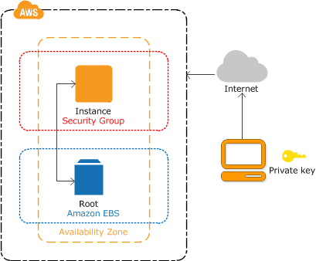

**Tasks**

To complete this tutorial, perform the following tasks:

1. [Launch an Instance](http://docs.aws.amazon.com/AWSEC2/latest/UserGuide/EC2_GetStarted.html#ec2-launch-instance)
2. [Connect to Your Instance](http://docs.aws.amazon.com/AWSEC2/latest/UserGuide/EC2_GetStarted.html#ec2-connect-to-instance-linux)
3. [Clean Up Your Instance](http://docs.aws.amazon.com/AWSEC2/latest/UserGuide/EC2_GetStarted.html#ec2-clean-up-your-instance)

**Related Tutorials**

* If you'd prefer to launch a Windows instance, see this tutorial in the *Amazon EC2 User Guide for Windows Instances*: [Getting Started with Amazon EC2 Windows Instances](http://docs.aws.amazon.com/AWSEC2/latest/WindowsGuide/EC2_GetStarted.html).
* If you'd prefer to use the command line, see this tutorial in the *AWS Command Line Interface User Guide*: [Using Amazon EC2 through the AWS CLI](http://docs.aws.amazon.com/cli/latest/userguide/cli-using-ec2.html).

Prerequisites

Before you begin, be sure that you've completed the steps in [Setting Up with Amazon EC2](http://docs.aws.amazon.com/AWSEC2/latest/UserGuide/get-set-up-for-amazon-ec2.html).

Step 1: Launch an Instance

You can launch a Linux instance using the AWS Management Console as described in the following procedure. This tutorial is intended to help you launch your first instance quickly, so it doesn't cover all possible options. For more information about the advanced options, see [Launching an Instance](http://docs.aws.amazon.com/AWSEC2/latest/UserGuide/launching-instance.html).

**To launch an instance**

1. Open the Amazon EC2 console at <https://console.aws.amazon.com/ec2/>.
2. From the console dashboard, choose **Launch Instance**.
3. The **Choose an Amazon Machine Image (AMI)** page displays a list of basic configurations, called *Amazon Machine Images (AMIs)*, that serve as templates for your instance. Select the HVM edition of the Amazon Linux AMI. Notice that this AMI is marked "Free tier eligible."
4. On the **Choose an Instance Type** page, you can select the hardware configuration of your instance. Select the t2.micro type, which is selected by default. Notice that this instance type is eligible for the free tier.

**Note**

[T2 instances](http://docs.aws.amazon.com/AWSEC2/latest/UserGuide/t2-instances.html), such as t2.micro, must be launched into a VPC. If your AWS account supports EC2-Classic and you do not have a VPC in the selected region, the launch wizard creates a VPC for you and you can continue to the next step. Otherwise, the **Review and Launch** button is disabled and you must choose **Next: Configure Instance Details** and follow the directions to select a subnet.

1. Choose **Review and Launch** to let the wizard complete the other configuration settings for you.
2. On the **Review Instance Launch** page, under **Security Groups**, you'll see that the wizard created and selected a security group for you. You can use this security group, or alternatively you can select the security group that you created when getting set up using the following steps:
   1. Choose **Edit security groups**.
   2. On the **Configure Security Group** page, ensure that **Select an existing security group** is selected.
   3. Select your security group from the list of existing security groups, and then choose **Review and Launch**.
3. On the **Review Instance Launch** page, choose **Launch**.
4. When prompted for a key pair, select **Choose an existing key pair**, then select the key pair that you created when getting set up.

Alternatively, you can create a new key pair. Select **Create a new key pair**, enter a name for the key pair, and then choose **Download Key Pair**. This is the only chance for you to save the private key file, so be sure to download it. Save the private key file in a safe place. You'll need to provide the name of your key pair when you launch an instance and the corresponding private key each time you connect to the instance.

**Warning**

Don't select the **Proceed without a key pair** option. If you launch your instance without a key pair, then you can't connect to it.

When you are ready, select the acknowledgement check box, and then choose **Launch Instances**.

1. A confirmation page lets you know that your instance is launching. Choose **View Instances** to close the confirmation page and return to the console.
2. On the **Instances** screen, you can view the status of the launch. It takes a short time for an instance to launch. When you launch an instance, its initial state is pending. After the instance starts, its state changes to runningand it receives a public DNS name. (If the **Public DNS (IPv4)** column is hidden, choose **Show/Hide Columns** (the gear-shaped icon) in the top right corner of the page and then select **Public DNS (IPv4)**.)
3. It can take a few minutes for the instance to be ready so that you can connect to it. Check that your instance has passed its status checks; you can view this information in the **Status Checks** column.

Step 2: Connect to Your Instance

There are several ways to connect to a Linux instance. In this procedure, you'll connect using your browser. Alternatively, you can connect using PuTTY or an SSH client. It's also assumed that you followed the steps earlier and launched an instance from an Amazon Linux AMI, which has a specific user name. Other Linux distributions may use a different user name. For more information, see [Connecting to Your Linux Instance from Windows Using PuTTY](http://docs.aws.amazon.com/AWSEC2/latest/UserGuide/putty.html) or [Connecting to Your Linux Instance Using SSH](http://docs.aws.amazon.com/AWSEC2/latest/UserGuide/AccessingInstancesLinux.html).

**Important**

You can't connect to your instance unless you launched it with a key pair for which you have the .pem file and you launched it with a security group that allows SSH access. If you can't connect to your instance, see[Troubleshooting Connecting to Your Instance](http://docs.aws.amazon.com/AWSEC2/latest/UserGuide/TroubleshootingInstancesConnecting.html) for assistance.

**To connect to your Linux instance using a web browser**

1. You must have Java installed and enabled in the browser. If you don't have Java already, you can contact your system administrator to get it installed, or follow the steps outlined in the following pages: [Install Java](http://java.com/en/download/help/index_installing.xml) and [Enable Java in your web browser](http://java.com/en/download/help/enable_browser.xml).
2. From the Amazon EC2 console, choose **Instances** in the navigation pane.
3. Select the instance, and then choose **Connect**.
4. Choose **A Java SSH client directly from my browser (Java required)**.
5. Amazon EC2 automatically detects the public DNS name of your instance and populates **Public DNS** for you. It also detects the key pair that you specified when you launched the instance. Complete the following, and then choose **Launch SSH Client**.
   1. In **User name**, enter ec2-user.
   2. In **Private key path**, enter the fully qualified path to your private key (.pem) file, including the key pair name.
   3. (Optional) Choose **Store in browser cache** to store the location of the private key in your browser cache. This enables Amazon EC2 to detect the location of the private key in subsequent browser sessions, until you clear your browser's cache.
6. If necessary, choose **Yes** to trust the certificate, and choose **Run** to run the MindTerm client.
7. If this is your first time running MindTerm, a series of dialog boxes asks you to accept the license agreement, confirm setup for your home directory, and confirm setup of the known hosts directory. Confirm these settings.
8. A dialog prompts you to add the host to your set of known hosts. If you do not want to store the host key information on your local computer, choose **No**.

A window opens and you are connected to your instance.

**Note**

If you chose **No** in the previous step, you'll see the following message, which is expected:

Verification of server key disabled in this session.

Step 3: Clean Up Your Instance

After you've finished with the instance that you created for this tutorial, you should clean up by terminating the instance. If you want to do more with this instance before you clean up, see [Next Steps](http://docs.aws.amazon.com/AWSEC2/latest/UserGuide/EC2_GetStarted.html#ec2-next-steps).

**Important**

Terminating an instance effectively deletes it; you can't reconnect to an instance after you've terminated it.

If you launched an instance that is not within the [AWS Free Tier](http://aws.amazon.com/free/), you'll stop incurring charges for that instance as soon as the instance status changes to shutting down or terminated. If you'd like to keep your instance for later, but not incur charges, you can stop the instance now and then start it again later. For more information, see [Stopping Instances](http://docs.aws.amazon.com/AWSEC2/latest/UserGuide/Stop_Start.html).

**To terminate your instance**

1. In the navigation pane, choose **Instances**. In the list of instances, select the instance.
2. Choose **Actions**, **Instance State**, **Terminate**.
3. Choose **Yes, Terminate** when prompted for confirmation.

Amazon EC2 shuts down and terminates your instance. After your instance is terminated, it remains visible on the console for a short while, and then the entry is deleted.

**EC2 Instance Types**

**Well you can't build a building without knowing all the building blocks, now can you**? You can't build an infrastructure.

You can't build an environment on AWS without knowing all of the components, especially the compute component portion.

**Understanding EC2 Instance Types (**3 pricing options)

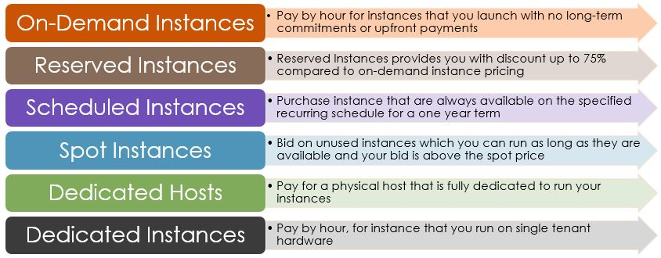

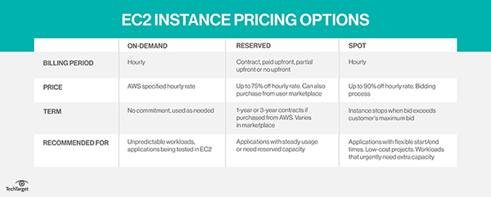

# Instance Purchasing Options

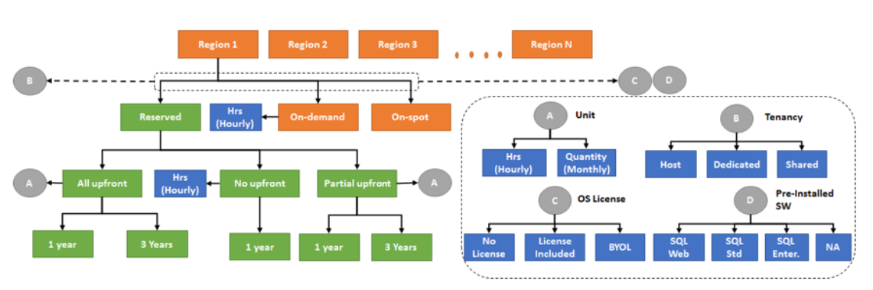

* **Scheduled Instances** – Purchase instances that are always available on the specified recurring schedule, for a one-year term.
* **Spot Instances** – Request unused EC2 instances, which can lower your Amazon EC2 costs significantly.

**On-demand**: Traditional one that you're used to.

**But that's the default one, kind of the on-demand one.**

They are useful for applications that may have unpredictable workloads or for test applications that are being deployed for the first time.

* It's the most expensive option. **And we're going to break it down.**
* Pay for the instances and the compute capacity that you use by the hour, with no long-term commitments or up-front payments
* The prices are going to vary by AWS region, so North America might not be the same as your upper Asia, etc.

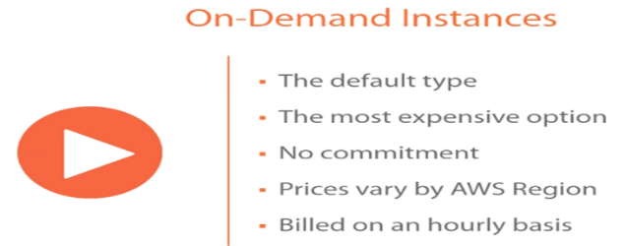

EX: Applications being developed or tested on Amazon EC2 for the first time

***Reserved Instances***A reserved instance is essentially the same as an on-demand instance except it has commit characteristics, which means you are committing to using this machine, this instance for an x amount of time.

Provide you with significant discounts as compared to On Demand Instances.

With Reserved Instances you reserve instances for a specific period of time with three payment options:

* No Upfront
* Partial Upfront
* Full Upfront

And two term lengths:

* One Year Term
* Three Year Term

The higher the upfront payment is, the more you save money. . And in exchange, you're getting a lower hourly rate. We're going to break that one down as well.

* Discounted usage price is fixed for as long as you own the Reserved Instance, allowing compute costs prediction over the term of the reservation.
* Reserved instances are best suited if **consistent, heavy, use is expected** and they can provide savings over owning your own hardware or running only On-Demand instances.
* Well Suited for
  + Applications with steady state or predictable usage
  + Applications that require reserved capacity
  + Users able to make upfront payments to reduce their total computing costs even further
* **Reserved Instances do not renew automatically, and the EC2 instances can be continued to be used but charged On-Demand rates**
* Auto Scaling or other AWS services can be used to launch the On-Demand instances that use the Reserved Instance benefits
* With Reserved Instances
  + **You pay for the entire term, regardless of the usage**
  + Once purchased, the reservation cannot be cancelled but can be sold in the Reserved Instance Marketplace
  + Reserved Instance pricing tier discounts only apply to purchases made from AWS, and not to the third party Reserved instances……..

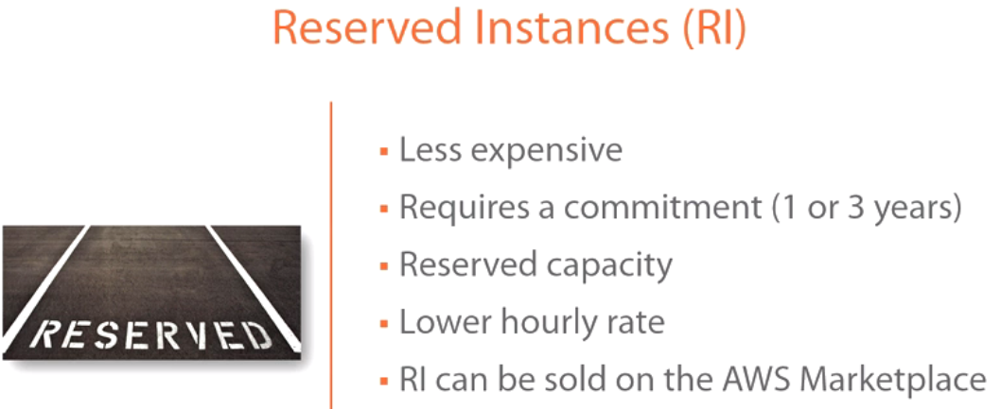

**A reserved instance**:

* Is less expensive.
* However, that less expensive requires a commitment. That commitment is either a 1- or 3-year commitment, so there is no 2-year. It's either a 1- or 3-year commitment. You're going to get a reserved capacity. So the advantage of a reserved instance not only is it going to give you a lower hourly rate because you're making this 1- or 3-year commitment.
* It’s also reserving the capacity, so it's ensuring if there is some run on an AWS availability zone, your capacity is reserved. AWS will never overprovision their availability zones and their data centers. As a result, when you're doing reserved instances, you are getting reserved capacity that machine will power on.
* You're getting a lower hourly rate.
* The reserved instances can also be sold on the AWS Marketplace.
* You're also committing to utilization with an RI.
* **Reserved instances are best suited if consistent, heavy, use is expected and they can provide savings over owning your own hardware or running only On-Demand instances.**
* **Well Suited for**
  + **Applications with steady state or predictable usage**
  + **Applications that require reserved capacity**
  + **Users able to make upfront payments to reduce their total computing costs even further**

**Understanding Hourly Billing**

* **Reserved Instances are billed for every hour during the term that you select, regardless of whether the instance is running or not.**
* *Reservations and discounted rates only apply to one instance-hour per hour.*

*-🡪 If an instance restarts during the first hour of a reservation and runs for two hours before stopping, the first instance-hour is charged at the discounted rate but three instance-hours are charged at the On-Demand rate.*

*If the instance restarts during one hour and again the next hour before running the remainder of the reservation, one instance-hour is charged at the On-Demand rate but the discounted rate is applied to previous and subsequent instance-hours.*

Consolidated Billing

* Pricing benefits of Reserved Instances are shared when the purchasing account is part of a set of accounts billed under one consolidated billing payer account
* Consolidated billing account aggregates the list value of member accounts within a region.
* When the list value of all active Reserved Instances for the consolidated billing account reaches a discount pricing tier, **any Reserved Instances purchased after this point by any member** of the consolidated billing account are charged at the discounted rate (as long as the list value for that consolidated account stays above the discount pricing tier threshold)

Buying Reserved Instances

Buying Reserved Instances need selection of the following

* **Platform** (for example, Linux)
* **Instance type** (for example, m1.small)
* **Availability Zone** in which to run the instance
* **Term** (time period) over which you want to reserve capacity
* **Tenancy** You can reserve capacity for your instance to run in single-tenant hardware (dedicated tenancy, as opposed to shared).
* **Offering** (No Upfront, Partial Upfront, All Upfront).

Modifying Reserved Instances

* Reserved Instances can be modified and continue to benefit from your capacity reservation, when the computing needs change.
* Modification does not change the remaining term of your Reserved Instances; their end dates remain the same.
* There is no fee, and you do not receive any new bills or invoices.
* Modification is separate from purchasing and does not affect how you use, purchase, or sell Reserved Instances.
* Complete reservation or a subset of it can be modified in one or more of the following ways:
  + Switch Availability Zones within the same region
  + Change between EC2-VPC and EC2-Classic
  + Change the instance size within the same instance type, given the instance size footprint remains the same *for e.g. four m1.medium instances (4 x 2), you can turn it into a reservation for eight m1.small instances (8 x 1) and vice versa. However, you cannot convert a reservation for a single m1.small instance (1 x 1) into a reservation for an m1.large instance (1 x 4).*

**Now spot instances:**

*Spot Instances*is a pricing option which enables you to bid on unused EC2 instances. The hourly price for a Spot Instance is set by AWS EC2, and it fluctuates according to the availability of the instances in a specific Availability zone.

* Basically, you will set a price for an instance above which you do not wish to get charged for.
* The price that you set is for per hour basis, therefore the moment the price for that instance becomes greater than what you have set, the instance gets shut down automatically.

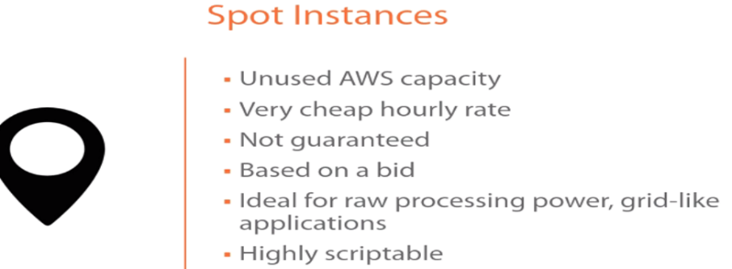

* These are available because of unused AWS capacity. So because AWS does not overcommit, they tend to end up with unused capacity, for example, at the end of the month or the end of the week, etc. This unused capacity, one of the ways that they put it to use, one of the ways that they monetize it is through the use of a spot instance
* .It's a very, very cheap hourly rate, and the reason it's cheap is, again, it's disposable. You can get outbid. If you get outbid, that means you're immediately going to lose access to this instance and somebody else is going to get access to it. So there's no notification, nothing.
* So it's not guaranteed. It's based on a bid, and
* It’s ideal for new processing power grid-like applications, maybe if you're mining for bitcoin, things that you can use on a mass scale. And if you lose nodes or instances, it doesn't really matter. That would be an ideal use case for a spot instance.

### **Spot Concepts**

* **Spot pool** – Pool of EC2 instances with the same instance type, availability zone, operating system and network platform
* **Spot price** – Current market price of a spot instance per hour as set by Amazon EC2 based on the last fulfilled bid
* **Spot bid** – is the maximum bid price the bidder is willing to pay for the spot instance
* **Spot fleet** – is the set of instances launched based on the criteria the bidder
* **Spot instance interruption** – EC2 terminates the spot instances whenever the bid price is lower than the current market price or the supply has reduced
* **Bid status** – provides the current state of the spot bid

### **Spot Pricing & How it works**

* EC2 sets up an hourly spot price which fluctuates depending upon the demand and supply.
* If the bid price exceeds the current market spot price, the request is fulfilled by Amazon till either the spot instance is terminated or the spot price increases beyond the bid price
* Everyone pays the same market price for the period irrespective of the bid price given the bid price is more than the spot price for e.g. if the spot price is $0.20 and there are 2 bids from Customers with bid price $0.25 and $0.30, both customers would still pay $0.20 only
* If the Spot instance is terminated by Amazon, you are not billed for the partial hour. However, if the spot instance are terminated by you, you will be charged for the partial hour
* Spot instances with a predefined duration use a fixed hourly price that remains in effect for the Spot instance while it runs
* EC2 can interrupt the Spot instance when the Spot price rises above your bid price, when the demand for Spot instances rises, or when the supply of Spot instances decreases.
* When EC2 marks a Spot instance for termination, it provides a Spot instance termination notice, which gives the instance a **two-minute warning** before it terminates.
* Termination notice warning is made available to the applications on the Spot instance using an item in the instance metadata termination-time attribute http://169.254.169.254/latest/meta-data/spot/termination-time and includes the time when the shutdown signal will be sent to the instance’s operating system
* Relevant applications on Spot Instances should poll for the termination notice at 5 second intervals, giving it almost the entire two minutes to complete any needed processing before the instance is terminated and taken back by AWS
* EBS-backed instance if it is a Spot instance cannot be stopped and started, but only rebooted or terminated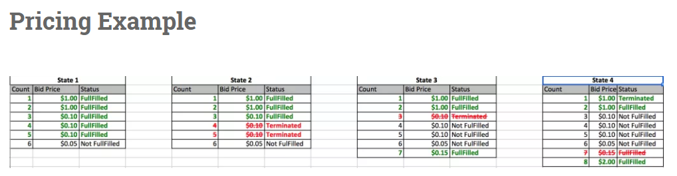
* **State 1** – Starting with Amazon EC2 has 5 Spot instances available
  + 6 bids available for Spot instances
  + Amazon EC2 picks up the top five priced bids and allocates a Spot instance to them
  + Spot Price is $0.10
  + Bid with the price of $0.05 is not served
* **State 2** – Supply of Amazon EC2 Spot instances reduce to 3
  + Amazon EC2 terminates the 2 spot instances with $0.10 ( the order in which the instances are terminated is determined at random )
  + Rest of the Spot instances continue
* **State 3** – New bid for Spot Instance is placed with Price $0.15 is placed
  + Spot instance with price $0.15 is fulfilled
  + Amazon EC2 terminates the single spot instances with $0.10
  + Spot Price changed to $0.15
* **State 4** New bid for Spot Instance is placed with Price $2 is placed
  + Spot instance with price $2 is fulfilled
  + Amazon EC2 terminates the single spot instances with $0.15
  + Spot Price changed to $1.00

**Spot Instances best practices**

* Choose a reasonable bid price, which is low enough to suit your budget and high enough for the request to be fulfilled and should not be higher than the On-Demand bid price
* Ensure the instances are up and ready as soon as the request is fulfilled, by provisioning an AMI with all the required softwares and load application data from user data
* Store important data regularly and externally in a place that won’t be affected by Spot instance termination *for e.g., use S3, EBS, or DynamoDB*
* Divide the work into smaller finer tasks so that they can be completely and state saved more frequently
* **Use Spot termination notice warning to monitor instance status regularly**
* **Test applications using On-Demand instances and terminating them to ensure that it handles unexpected termination gracefully**
* **Dedicated Instances** are EC2 instances that run in a VPC on hardware that’s dedicated to a single customer
* Dedicated Instances are physically isolated at the host hardware level from the instances that aren’t Dedicated Instances and from instances that belong to other AWS accounts.
* Each VPC has a related instance tenancy attribute, and can’t be changed after the VPC has been created. Default is shared
* Each instance launched into a VPC has a tenancy attribute, can’t be changed after the instance is launched. Default tenancy depends on the VPC tenancy.
* Dedicated Instances can be launched using
  + Create the VPC with the instance tenancy set to dedicated, all instances launched into this VPC are Dedicated Instances even though if you mark the tenancy as shared
  + Create the VPC with the instance tenancy set to default, and specify dedicated tenancy for any instances that should be Dedicated Instances when you launch them.

**Dedicated Instances**

* They are the instances that run on single-tenant hardware dedicated to a single customer.
* They are perfect for workloads where a corporate policy or industry regulation requires that your instance should be isolated from any other customer’s instance, therefore they go for their own separate machines, and their instances are isolated at the hardware level.

Let’s understand this through an example. Suppose in our company Edureka, we have the following tasks:

* Analysis of customer’s data
  + Customer’s website activity, etc. should all be monitored in real-time. There will be times when the traffic on the website will be minimum, therefore using a very powerful processor should not be considered, since it will become expensive for the company because it will not be used for every hour of the day. Hence, for this task, we might take **t2 instances**because they give **Burstable CPU performance** i.e when the traffic will be more the CPU performance will be increased accordingly to meet the requirements.
* Our auto-response emailing system
  + It should be quick, therefore we would require systems, where the response time is as short as possible. This could be achieved by using **EBS optimized instances**, as they offer high IOPS and hence, low latencies.
* The search engine on our website
  + It should be able to sort the keywords and return relevant results, therefore we might have 2 servers for this. One is the database and the other server for processing the keywords. Therefore, the communication between these servers should be at the maximum possible rate. To achieve this, we can put them in a placement group and for that we have to use**Cluster Networking Instances.**
* Some processes in every organisation are highly confidential
  + Because these processes give us an edge over other companies, no matter how secure the servers, maybe, some policies are still made to be sure. Therefore, we might use **Dedicated Instances** for these kind of processes.

**EC2 instance family:**

#### Current and Previous generation Instance Types

| **Instance Family** | **Current Generation Instance Types** |
| --- | --- |
| General purpose | t2.nano | t2.micro | t2.small | t2.medium | t2.large | m4.large |m4.xlarge | m4.2xlarge | m4.4xlarge | m4.10xlarge | m3.medium |m3.large | m3.xlarge | m3.2xlarge |
| Compute optimized | c4.large | c4.xlarge | c4.2xlarge | c4.4xlarge | c4.8xlarge |c3.large | c3.xlarge | c3.2xlarge | c3.4xlarge | c3.8xlarge |
| Memory optimized | r3.large | r3.xlarge | r3.2xlarge | r3.4xlarge | r3.8xlarge |x1.32xlarge |
| Storage optimized | i2.xlarge | i2.2xlarge | i2.4xlarge | i2.8xlarge | d2.xlarge |d2.2xlarge | d2.4xlarge | d2.8xlarge |
| GPU instances | g2.2xlarge | g2.8xlarge |
| Micro instances |  |

#### Hardware Specifications

|  |  |
| --- | --- |
| **Instance Family** | **Hardware Specification** |
| General purpose (T2) | High Frequency Intel Xeon Processors with Turbo up to 3.3GHz  Burstable CPU, governed by CPU Credits, and consistent baseline performance |
| General purpose (M4) | 2.4 GHz Intel Xeon® E5-2676 v3 (Haswell) processors  EBS-optimized by default at no additional cost  Support for Enhanced Networking |
| General purpose (M3) | High Frequency Intel Xeon E5-2670 v2 (Ivy Bridge) Processors*  SSD-based instance storage for fast I/O performance |
| Compute optimized (C4) | High frequency Intel Xeon E5-2666 v3 (Haswell) processors optimized specifically for EC2  EBS-optimized by default and at no additional cost  Ability to control processor C-state and P-state configuration on the c4.8xlarge instance type |
| Compute optimized (C3) | High Frequency Intel Xeon E5-2680 v2 (Ivy Bridge) Processors  Support for [Enhanced Networking](https://aws.amazon.com/ec2/instance-types/#enhanced_networking?tag=s3bucketscom-21)  Support for clustering |
| Memory optimized (X1) | High Frequency Intel Xeon E7-8880 v3 (Haswell) Processors  Lowest price per GiB of RAM  1,952 GiB of DDR4-based instance memory  SSD Storage and EBS-optimized by default and at no additional cost |
| Memory optimized (R3) | High Frequency Intel Xeon E5-2670 v2 (Ivy Bridge) Processors  SSD Storage |
| Storage optimized (I2) | High Frequency Intel Xeon E5-2670 v2 (Ivy Bridge) Processors  SSD Storage & Support for TRIM |
| Storage optimized (D2) | High-frequency Intel Xeon E5-2676v3 (Haswell) processors  HDD storage  Consistent high performance at launch time  High disk throughput |
| GPU instances | High Frequency Intel Xeon E5-2670 (Sandy Bridge) Processors  High-performance NVIDIA GPUs, each with 1,536 CUDA cores and 4GB of video memory  Each GPU features an on-board hardware video encoder designed to support up to eight real-time HD video streams (720p@30fps) or up to four real-time full HD video streams (1080p@30fps) |

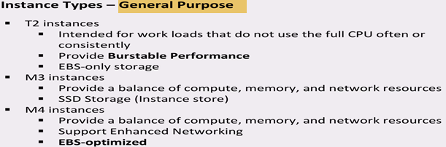

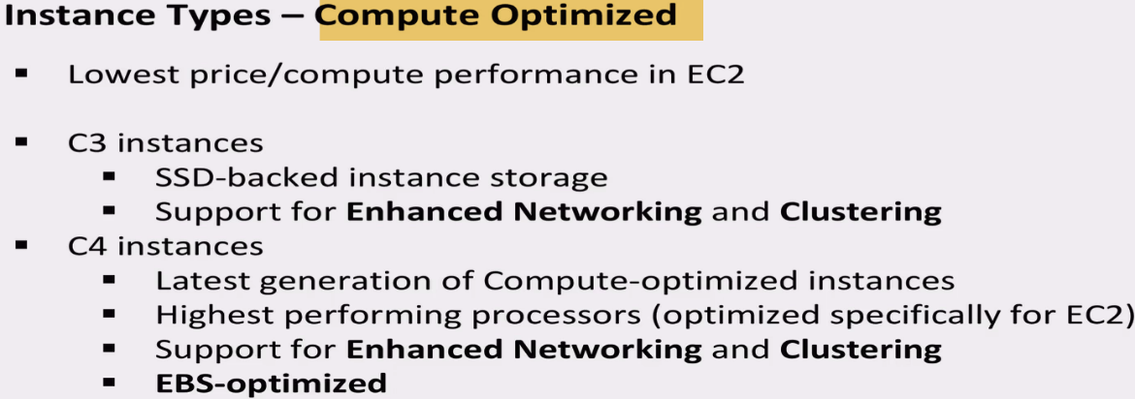

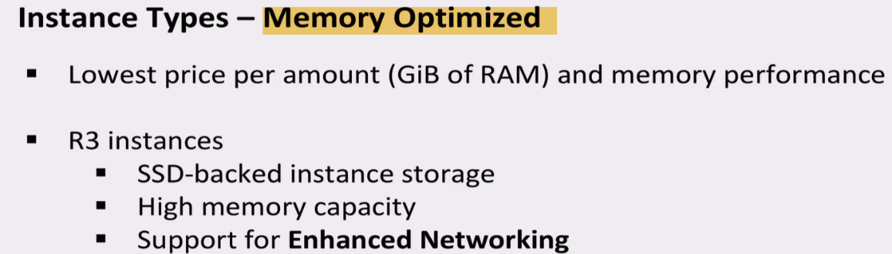

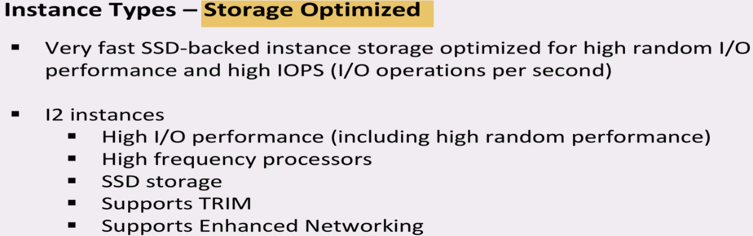

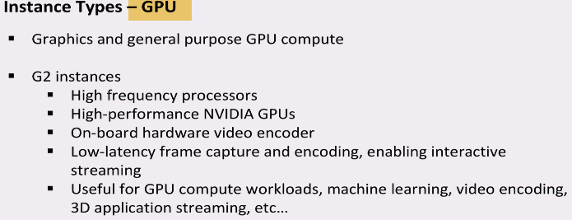

Computing is a very broad term, the nature of your task decides what kind of computing you need.

Therefore, AWS EC2 offers 5 types of instances which are as follows:

* *General Instances*
  + For applications that require a balance of performance and cost.
    - E.g email responding systems, where you need a prompt response as well as the it should be cost effective, since it doesn’t require much processing.
* *Compute Instances*
  + For applications that require a lot of processing from the CPU.
    - E.g analysis of data from a stream of data, like Twitter stream
* *Memory Instances*
  + For applications that are heavy in nature, therefore, require a lot of RAM.
    - E.g when your system needs a lot of applications running in the background i.e multitasking.
* *Storage Instances*
  + For applications that are huge in size or have a data set that occupies a lot of space.
    - E.g When your application is of huge size.
* *GPU Instances*
  + For applications that require some heavy graphics rendering.
    - E.g 3D modelling etc.

**Now, every instance type has a set of instances which are optimized for different workloads:**

* General Instances
  + t2
  + m4
  + m3
* Compute Instances
  + c4
  + c3
* Memory Instances
  + r3
  + x1
* Storage Instances
  + i2
  + d2
* GPU Instances
  + g2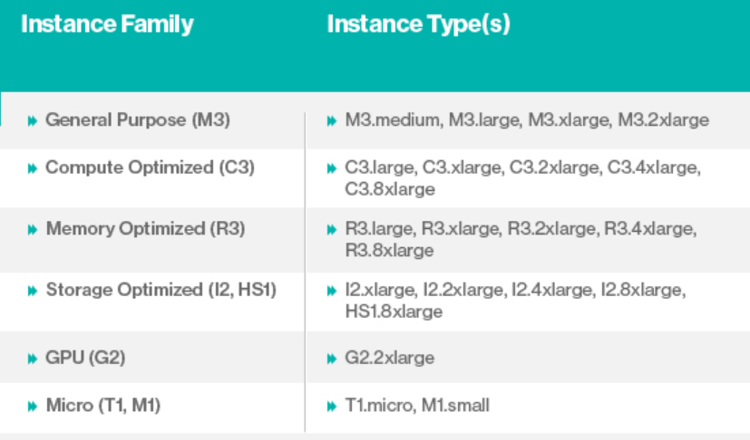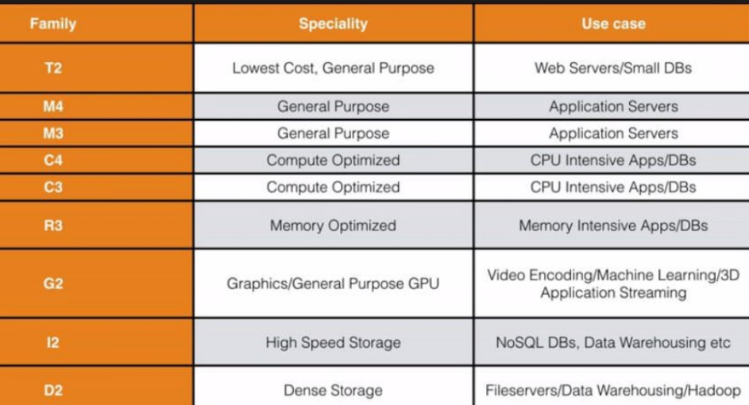

Now let’s understand the kind of work that each instance is optimized for, in this AWS EC2 Tutorial:

**Burstable Performance Instances**

* *T2 instances* are burstable instances, meaning the CPU performs at a baseline, say 20% of its capability. When your application needs more than 20% of the performance of the CPU, the CPU enters into a burst mode giving higher performance for a limited amount of time, therefore work happens faster.
  + You get these credits when your CPU is idle.
  + Each CPU credit gives a burst of 1 minute to the CPU.
  + If your CPU credits are not used they are credited to your account and they stay there for 24 hours.
  + Based on your credit balance, you can decide whether the t2 instance, should be scaled up or down.
  + These bursts happen at a cost, every time a burst happens in a CPU, CPU credits are used.

### EBS-optimized Instances

* *C4, M4, and D2 instances*, are EBS optimized by default, EBS means Elastic Block Storage, which is a storage option provided by AWS in which the IOPS* rate is quite high. Therefore, when an EBS volume is attached to an optimized instance, single digit millisecond latencies can be achieved.

*IOPS (Input/Output Operations Per Second, pronounced eye-ops) is a performance measurement used to characterize computer storage devices.

**Cluster Networking Instances**

* *X1, M4, C4, C3, I2, G2 and D2 instances* support cluster networking. Instances launched into a common placement groupare put in a logical group that provides high-bandwidth, low latency between all the instances in the group.
  + A placement group is basically a logical cluster where some select EC2  instances which are a part of that group can utilize up to 10Gbps for single flow and 20Gbps for multi flow traffic in each direction.
  + Instances which are not a part of that group are limited to 5 Gbps speed in multi flow traffic. Cluster Networking is ideal for high performance analytics system.

Now when you go to provision an EC2 instance, there are different types of families..

An instance family is essentially a grouping of resources. In the general purpose, it's a little balance between CPU, memory, and disk. 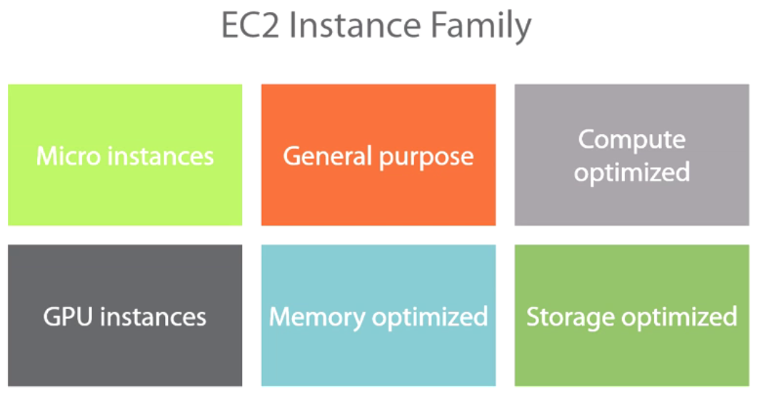

So for starters, you have **micro instances**. That's family---that's the lowest, and you're **not** going to get very good performance out of it. It's not very predictable, so that's the low-end. Typically, you're going to get this with the free tier.

**General purpose:** General purpose is a lot more stable. It gives you more memory, CPU configuration so you get a better configuration.

**Compute optimized**: it skews in the favor of compute, so it's a lot more compute heavy as opposed to being anything else, as opposed to being memory heavy.

**GPU instances**. Those are going to have a graphical processing unit in it. And those can be used for specific workload, specific use cases.

**Memory optimized** machines that are heavy on memory, maybe less on CPU

**Storage optimized virtual instances** as well that are going to be heavy on the storage and less on other resources.

**Sizes and different configurations.**

So the general purpose---in general purpose, you're going to have two types of families. You're going to have the t, and you're going to have the m families.

This is the micro, again the cheapest level, typically the free tier. You're not going to get very good performance out of it. And then you have the m tier. And within the m family, the m3 family, you're going to have x1, x2, x3, so you're going to have multiple levels of configurations. This applies to the compute.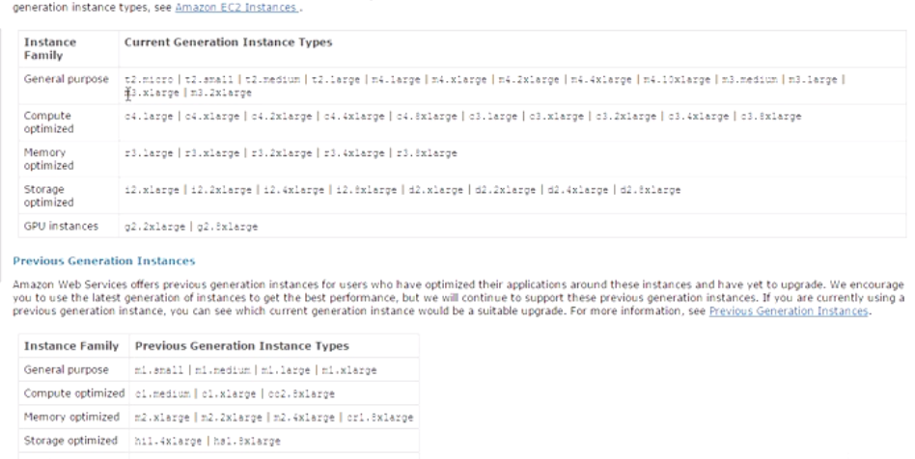

c3 means compute optimized, an r3 means memory optimized, an i2 means storage optimized, and so on and so forth, g2 means GPU optimized.

**EC2 Instance Types Walkthrough in the AWS Management Console**

Management Console-> on-demand instance (Default)-> click on Launch Instance-> Windows Server 2012 R2->Down here you're going to get all of the instance families and their configurations, 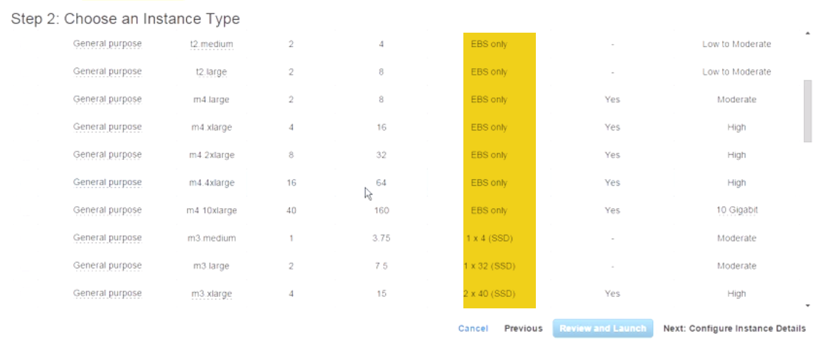

For example, the free tier, this one is the general purpose again. It's **a t2 micro. You're getting 1 vCPU. You're getting essentially 1 GB of memory** and so on and so forth. It's EBS, elastic block storage.

m4 here: two virtual CPUs, 8 GB of memory. It's EBS again and so on and so forth.

You can keep going down. This one is compute optimized, so you're getting a lot more compute here. You're still getting a ton of memory, but you see what I mean. And you can keep going down. I mean this one is giving you a ton of memory. You're getting 244 GB of memory here. So you can see how this works. The storage, again, they're giving you SSD here.

**Reserved instances**.

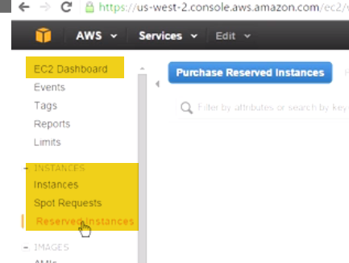 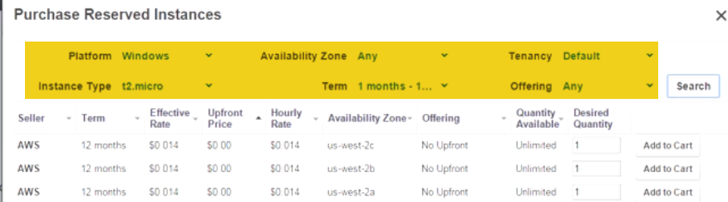

Purchasing a reserved instance is easy.

Click on Purchase Reserved Instance.

You're going to select the parameters to figure out what the pricing looks like.

* So, for example, if we wanted to select one that was Windows, and you see there're different options in here. You can **select Platform Windows.**
* **The instance type,** for example, we're buying this for a t2 micro. If you were buying it for a different instance that you have already provisioned, then you would select that from the list here, and you have all of the families that are listed,
* **Availability zone.**
* **From a term perspective:** recall I said you could only do either 12 months or 36 months, so one year or three years. Let's go ahead and select one year, for example.
* **From a tenancy perspective**, if you wanted to do hardware or dedicated, you could do that. I'm just going to keep it at default.
* **Offering perspective:**

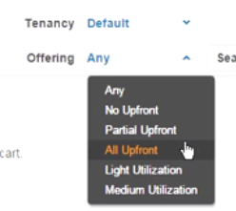

I'm just going to keep it at any just to get some numbers here.

* And when you're ready with the criteria, you can click on **Search**, and it's going to give you a list of what you can purchase from a reserved instance for this and then apply it to an instance.

It's giving you the upfront price and how it varies if you put some money down. You can start to see how it varies from an effective rate perspective. You're also seeing the hourly rate, and you're seeing how that gets fluctuated based, again, on how much you put down. This is the availability zone.

**When do you use a reserved instance?**

You use a reserved instance when you know that you're already going to use this particular instance for a year. If you're going to use it for a year anyway, might as well **purchase a reserved instance for it because you're going to lower your hourly rate.** And then based on the utilization--light or medium or high--then if you're going to have it powered on all day, are you going to power down sometimes?, etc.

I don't recommend that you purchase the three-year term, although the three-year term will give you the highest level of discount possible. And the reason I don't recommend it is because if you look historically at how many types AWS has cut prices, if you're locked into a reserved instance and they happen to cut prices, then you don't take advantage of that.

**Spot instances:** click on Spot Requests🡪click on Request Spot Instance, then you're going to select the (AMI.)Windows Server 2012, 🡪( instance family). What are you looking to figure---to bid on? I'm going to go with the free one just to keep things simple.

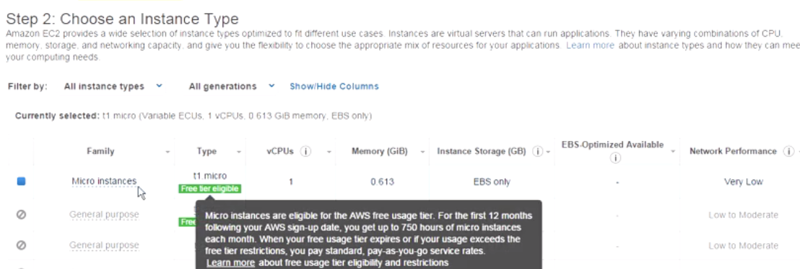 Next to configure it. You go through the configuration, and here what you're going to see is:

How many do you want? How many spot instances to you want? : 1.

* You're requesting a spot instance.
* This is the current price.
* Now, what is the maximum price? What is the maximum bid that you're willing to pay for this instance? So maybe in my case I will do 0.0065 here just to kind of outbid the minimum bid.
* Again if you wanted to be part of a group, then you're saying that I want all of the instances that I'm provisioning to launch at the same time because I'm only provisioning one, this isn't going to apply to me at this point.
* The request is valid from, you can specify, and the request is valid to, you can also specify.
* And you can make this a persistent request, which means every time you fulfil this, every time the bid is--- the maximum bid is this, it's automatically going to submit a request for spot instances.
* So you can have this kind of in a repetitive format.
* The network that you want to put this in, again, which VPC? I'm just going to keep it at default. I'm going to keep everything at default--VPC and subnet.
* As far as auto-assign IP address, again, I'm going to leave it at default here. But from the drop-down menu, you can enable or disable it if you choose to do that.
* I'm not going to assign anything from an IAM perspective, and I'm not going to do anything from a monitoring perspective either.
* Under Advanced, I'm also not going to do any kind of advanced settings here. I just want to show you how this kind of works.
* Now, once you're ready, we're going to go to Review.

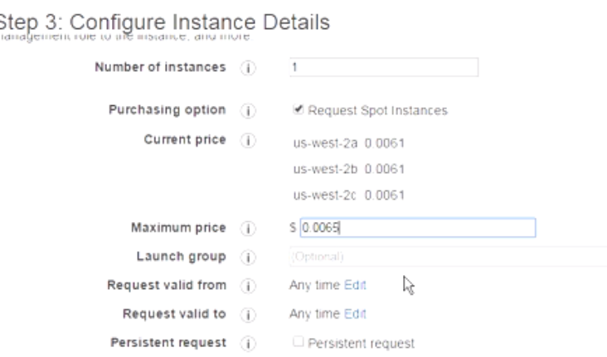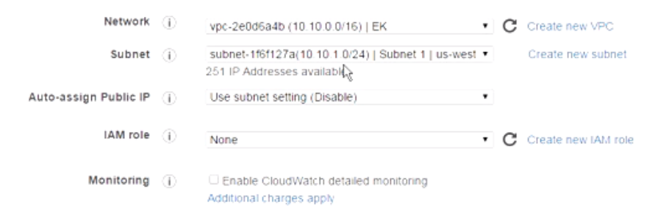

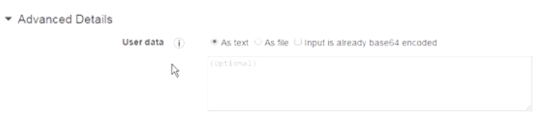Now you're going to select the key pair here. I already have the WBC key pair. I acknowledge that I have it. And let's 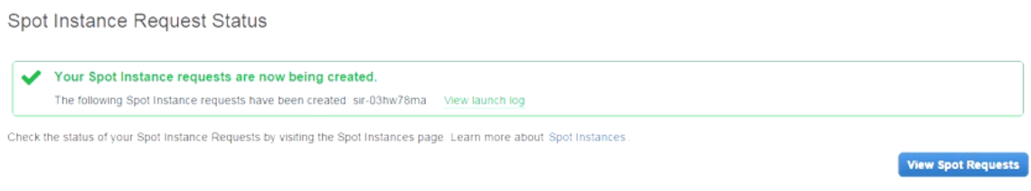 go ahead and request a spot instance. The request has been submitted. You can go here to view the spot instances. 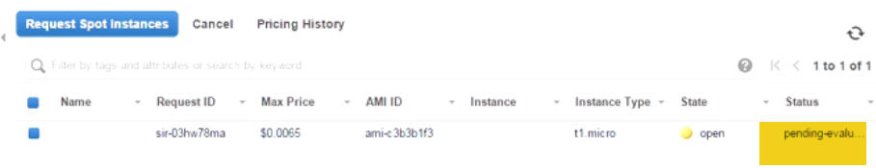Right now it's pending, so the request has not been fulfilled yet. Once the request has been fulfilled, then you're able to go to your instances, and you're able to launch your instances in a regular way.

**Now keep in mind, if someone outbids you, then it's not going to notify you that, Hey, somebody outbid you. It's just going to essentially drop you, and it's going to give that instance to somebody else. So just keep that in mind when you're using spot instances.**

Let's go ahead and refresh this. I don't think this is going to fulfil any time soon here. So this might take a little time, again, to fulfil..

Once this is fulfilled, then if you go to Instances here, 

You’ll see that your instance populates, and then you can launch it and then just run it the same way that we've done with others. 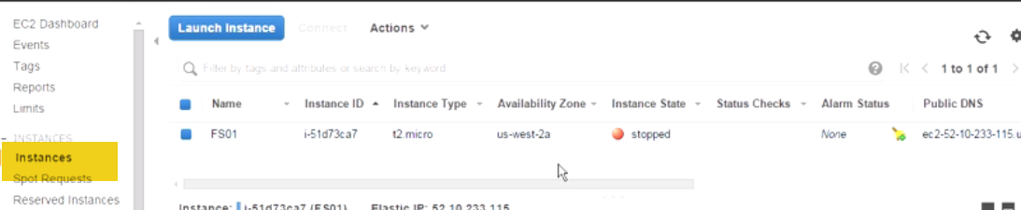

If you wanted to cancel this particular request, then, again, it's pretty easy. Goto SpotInstances->You can click on the Cancel button up here. You can also right-click and click on Cancel and just come down here it says, Yes, cancel this. 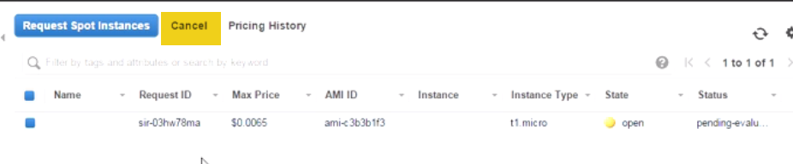

Now if you cancel it, also remember to go back into Instance and terminate that instance just to be on the safe side. So, again, some things to massage when you're dealing with spot instances.

**Module Summary**

We started off by talking about the instance types. We talked about the fact that you have on-demand, you have reserved instances, and you have spot instances.

We also talked about different characteristics, what you get with each, the hourly rate, how that changes, what are the different pricing models, what you get with RI versus spot, etc.

And then we moved on to move on to talk about EC2 instance families. We talked about the general purpose, the compute optimize, the micro, the memory optimize, the GPU optimize, the storage optimize.

**Understanding AWS Instance Types, Utilization, and Performance**

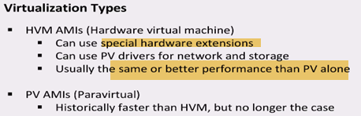

HVM uses special hardware extensions, that increase performance

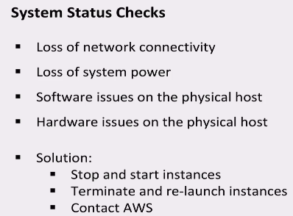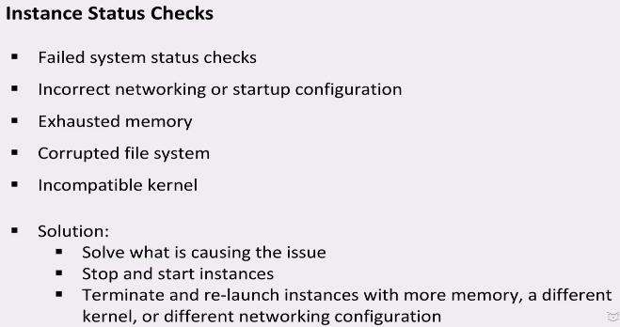



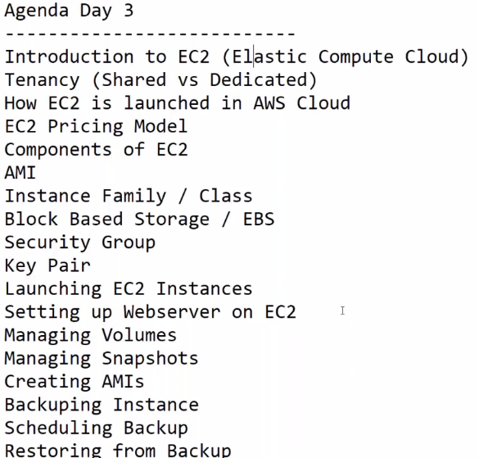

Instance* hrs* days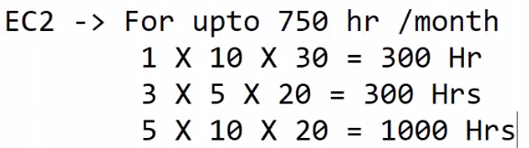 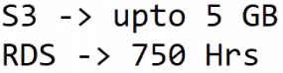

Elastic Cloud Compute – EC2 Overview

* Elastic Compute Cloud (EC2) **provides scalable computing capacity in the Amazon Web Services (AWS) cloud.**
* EC2 eliminates the need to invest in **hardware up front**, so applications can be developed and deployed faster.
* EC2 can be used to **launch as many or as few virtual servers as you need,** configure security and networking, and manage storage.
* EC2 enables you to **scale up or down to handle** changes in requirements or spikes in popularity, reducing your need to forecast traffic.

EC2 features

* Virtual computing environments, known as ***Ec2 instances***
* Preconfigured templates for your instances, known as ***Amazon Machine Images (AMIs)***, that package the bits you need for your server (including the operating system and additional software)
* Various configurations of CPU, memory, storage, and networking capacity for your instances, known as ***Instance types***
* Secure login information for your instances using ***key pairs*** (AWS stores the public key, and you store the private key in a secure place)
* Storage volumes for temporary data that’s deleted when you stop or terminate your instance, known as ***Instance store volumes***
* Persistent storage volumes for your data using Amazon Elastic Block Store (Amazon EBS), known as ***Amazon EBS volumes***
* Multiple physical locations for your resources, such as instances and Amazon EBS volumes, known as ***Regions and Availability Zones***
* A firewall that enables you to specify the protocols, ports, and source IP ranges that can reach your instances using ***security groups***
* Static IP addresses for dynamic cloud computing, known as ***Elastic IP addresses***
* Metadata, known as ***tags***, can be created and assigned to EC2 resources
* Virtual networks you can create that are logically isolated from the rest of the AWS cloud, and that you can optionally connect to your own network, known as **Virtual private clouds (VPCs)**

Accessing EC2

* Amazon EC2 console
  + Amazon EC2 console is the web-based user interface which can be accessed from AWS management console
* AWS Command line Interface (CLI)
  + Provides commands for a broad set of AWS products, and is supported on Windows, Mac, and Linux.
* Amazon EC2 Command Line Interface (CLI) tools
  + Provides commands for Amazon EC2, Amazon EBS, and Amazon VPC, and is supported on Windows, Mac, and Linux
* AWS Tools for Windows Powershell
  + Provides commands for a broad set of AWS products for those who script in the PowerShell environment
* AWS Query API
  + Query API allows for requests are HTTP or HTTPS requests that use the HTTP verbs GET or POST and a Query parameter named Action
* AWS SDK libraries
  + AWS provide libraries in various languages which provide basic functions that automate tasks such as cryptographically signing your requests, retrying requests, and handling error responses.

# **AWS EC2 Amazon Machine Image**

* **An AMI is basically an template and can be used to launch as many instances as needed**
* Within an VPC, instances can be launched from as many different AMIs
* An AMI includes the following:

1. A template for the root volume for the instance for e.g. an operating system, an application server, and applications
2. Launch permissions that control which AWS accounts can use the AMI to launch instances for e.g. AWS **account ids with whom the AMI is shared**
3. **A block device mapping that specifies the volumes to attach to the instance when it’s launched**

* AMIs can be either

1. AWS managed, provided and published AMIs
2. **Third party or Community** provided public custom AMIs
3. **Private AMIs created by other AWS accounts and shared with you**
4. **Private and Custom AMIs created by you**

* AMI lifecycle

1. After you create and register an AMI
2. you can use it to launch new instances. (You can also launch instances from an AMI if the AMI owner grants you launch permissions.)
3. You can copy an AMI to the same region or to different regions.
4. When you are finished launching instance from an AMI, you can deregister the AMI

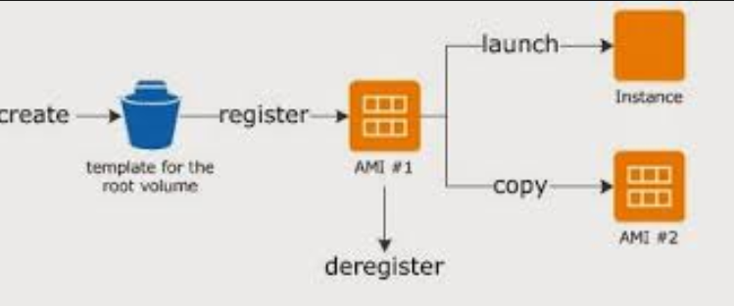

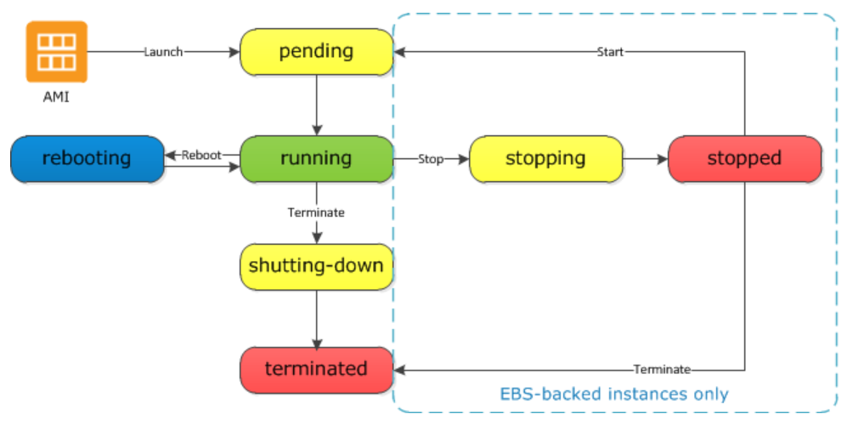

* Pending
  + When the instance is first launched is enters into the **pending** state
* Running
  + After the instance is launched, it enters into the **running** state
  + Charges are incurred for every hour or partial hour the instance is running even if it is idle
* Start & Stop (EBS-backed instances only)
  + Only and EBS-backed instance can be stopped and started. Instance store-bakced instance cannot be stopped and started
  + An instance can stopped & started in case the instance fails a status check or is not running as expected
  + Stop
    - After the instance is stopped, it enters in stopping state and then to stopped state.
    - Charges are only incurred for the EBS storage and not for the instance hourly charge or data transfer.
    - While the instance is stopped, you can treat its root volume like any other volume, and modify it *for e.g. repair file system problems or update software or change the instance type, user data, EBS otpmization attributes etc*
    - Volume can be detached from the stopped instance, and attached to a running instance, modified, detached from the running instance, and then reattached to the stopped instance. It should be reattached using the storage device name that’s specified as the root device in the block device mapping for the instance.
  + Start
    - When the instance is started, it enters into pending state and then into running
    - An instance when stopped and started is launched on a new host
    - Any data on an instance store volume (not root volume) would be lost while data on the EBS volume persists
  + EC2 instance retains its private IP address as well as the Elastic IP address. However, the public IP address, if assigned instead of the Elastic IP address, would be released
  + Charges for full hour are incurred for every transition from stopped to running, even if the transition is within the same hour *for e.g. if you stop and start your instances 2 times in an hour, you would be charged for 3 full hours, one for the start and then for the 2 transitions as if you had 3 instances running during that hour*
* Instance reboot
  + Both EBS-backed and Instance store-backed instances can be rebooted
  + An instance retains it public DNS, public and private IP address during the reboot
  + Data on the EBS and Instance store volume is also retained
  + Amazon recommends to use Amazon EC2 to reboot the instance instead of running the operating system reboot command from your instance as it performs a hard reboot if the instance does not cleanly shutdown within four minutes also creates an API record in CloudTrail, if enabled.
* Instance retirement
  + An instance is scheduled to be retired when AWS detects irreparable failure of the underlying hardware hosting the instance.
  + When an instance reaches its scheduled retirement date, it is stopped or terminated by AWS.
  + If the instance root device is an Amazon EBS volume, the instance is stopped, and can be started again at any time.
  + If the instance root device is an instance store volume, the instance is terminated, and cannot be used again.
* Instance Termination
  + An instance can be terminated, and it enters into the shutting-down and then the terminated state
  + After an instance is terminated, it can’t be connected and no charges are incurred
  + Instance Shutdown behaviour
    - **EBS-backed instance** supports **InstanceInitiatedShutdownBehavior**attribute which determines whether the instance would be stopped or terminated when a shutdown command is initiated from the instance itself *for e.g. shutdown, halt or poweroff command in linux*.
    - Default behaviour for the the instance to be stopped.
    - A shutdown command for an Instance store-backed instance will always terminate the instance
  + **Termination protection**
    - Termination protection (DisableApiTermination attribute) can be enabled on the instance to prevent it from being accidently terminated
    - DisableApiTerminationfrom the Console, CLI or API.
    - Instance can be terminated through Amazon EC2 CLI.
    - Termination protection does not work for instances when
      * part of an Autoscaling group
      * launched as Spot instances
      * terminating an instance by initiating shutdown from the instance
  + Data persistence
    - EBS volume have a DeleteOnTermination attribute which determines whether the volumes would be persisted or deleted when an instance they are associated with are terminated
    - Data on Instance store volume data does not persist
    - Data on EBS root volumes, have the DeleteOnTermination flag set to true, would be deleted by default
    - Additional EBS volumes attached have the DeleteOnTermination flag set to false are not deleted but just detached from the instance

## Differences Between Reboot, Stop, and Terminate

|  |  |  |  |
| --- | --- | --- | --- |
| **Characteristic** | **Reboot** | **Stop/start (Amazon EBS-backed instances only)** | **Terminate** |
| Host computer | The instance stays on the same host computer | In most cases, we move the instance to a new host computer. Your instance may stay on the same host computer if there are no problems with the host computer. | None |
| Private and public IPv4 addresses | These addresses stay the same | EC2-Classic: The instance gets new private and public IPv4 addresses  EC2-VPC: The instance keeps its private IPv4 address. The instance gets a new public IPv4 address, unless it has an Elastic IP address, which doesn't change during a stop/start. | None |
| Elastic IP addresses (IPv4) | The Elastic IP address remains associated with the instance | EC2-Classic: The Elastic IP address is disassociated from the instance  EC2-VPC: The Elastic IP address remains associated with the instance | The Elastic IP address is disassociated from the instance |
| IPv6 address (EC2-VPC only) | The address stays the same | The instance keeps its IPv6 address | None |
| Instance store volumes | The data is preserved | The data is erased | The data is erased |
| Root device volume | The volume is preserved | The volume is preserved | The volume is deleted by default |
| Billing | The instance billing hour doesn't change. | You stop incurring charges for an instance as soon as its state changes to stopping. Each time an instance transitions from stopped to running, we start a new instance billing period, billing a minimum of one minute every time you restart your instance. | You stop incurring charges for an instance as soon as its state changes to shutting-down. |

Operating system shutdown commands always terminate an instance store-backed instance. You can control whether operating system shutdown commands stop or terminate an Amazon EBS-backed instance.

**AMI Types**

1. Region & Availability Zone
   * AMIs are specific to a region and if needed in another region must be copied over
2. Operating system
   * AMIS are available in a variety of OS flavors *for e.g. linux, windows, ubuntu etc*
3. Architecture (32-bit or 64-bit)
4. Launch Permissions
   * Launch permissions define who has access to the AMI
     + Public – Accessible to all AWS accounts
     + Explicit – Shared with specific AWS accounts
     + Private – Owned and available for AMI creator AWS account only
5. Root device storage
   * **AMIs can have EBS or Instance store as the root device storage**

* EC2 Instances can be launched using either Elastic Block Store (EBS) or Instance Store volume as root volumes and additional volumes.
* EC2 instances can be launched by choosing between AMIs backed by Amazon EC2 instance store and AMIs backed by Amazon EBS. However, AWS recommends use of AMIs backed by Amazon EBS, because they launch faster and use persistent storage.

Here's where to use each:

* **Use EBS for the backing OS partition and permanent storage (DB data, critical logs, application config)**
* **Use instance storage for in-process data, noncritical logs, and transient application state. Example: external sort storage, tempfiles, etc.**
* **Instance storage can also be used for performance-critical data, when there's replication between instances (NoSQL DBs, distributed queue/message systems, and DBs with replication)**
* **Use S3 for data shared between systems: input dataset and processed results, or for static data used by each system when lauched.**
* **Use AMIs for prebaked, launchable servers**

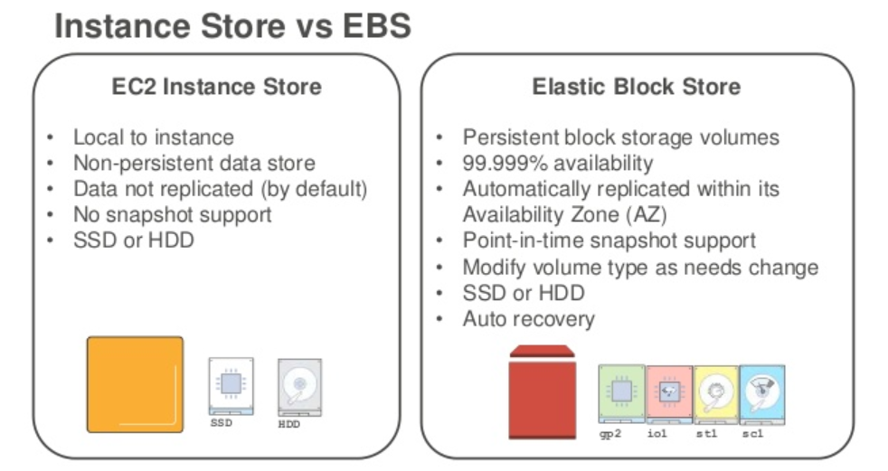

**Store (Ephemeral storage)**

If an instance reboots (intentionally or unintentionally), data in the instance store persists.

1. **Data on Instance store volume is NOT LOST when the instance is rebooted**

The data in an instance store persists only during the lifetime of its associated instance

However, data in the instance store is lost under the following circumstances:

* The underlying disk drive fails
* The instance stops
* The instance terminates

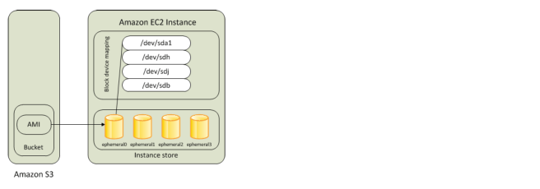

* An Instance store backed instance is an EC2 instance using an Instance store as root device volume created from a template stored in Amazon S3.
* Instance store volumes accesses storage from disks that are physically attached to the host computer.
* When an Instance stored instance is launched, the image that is used to boot the instance is copied to the root volume (typically sda1).
* Instance store provides temporary block-level storage for instances.
* Data on an instance store volume persists only during the life of the associated instance; if an instance is stopped or terminated, any data on instance store volumes is lost.

**Key points for Instance store backed Instance**

1. Boot time is slower then EBS backed volumes and usually less then 5 min
2. Can be selected as Root Volume and attached as additional volumes
3. Instance store backed Instances can be of maximum 10GiB volume size
4. Instance store volume can be attached as additional volumes only when is the Instance is being launched and cannot be attached once the Instance is up and running
5. Instance store backed Instances cannot be stopped as one of the main reason being when stopped and started AWS does not guarantee the Instance would be launched in the same host.
6. Data on Instance store volume is **LOST** in following scenarios :-
   * Failure of an underlying drive
   * Stopping an EBS-backed instance where instance store are additional volumes
   * Termination of the Instance
7. AMI creation requires usage on AMI tools and needs to be executed from within the server
8. Instance store backed Instances cannot be upgraded

**Amazon Elastic Block Store (EBS)**

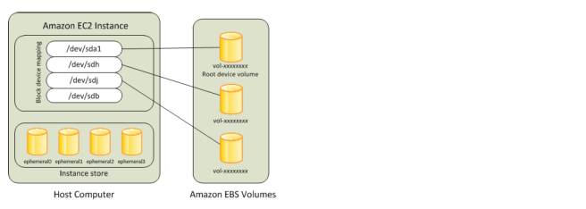

EBS is like the virtual disk of a VM:

* Durable, instances backed by EBS can be freely started and stopped (saving money)
* Can be snapshotted at any point in time, to get point-in-time backups
* **AMIs can be created from EBS snapshots, so the EBS volume becomes a template for new systems**
* EBS backed instances can be set so that they cannot be (accidentally) terminated through the API.
* EBS backed instances can be stopped when you're not using them and resumed when you need them again (like pausing a Virtual PC), at least with my usage patterns saving much more money than I spend on a few dozen GB of EBS storage.
* EBS backed instances don't lose their instance storage when they crash (not a requirement for all users, but makes recovery much faster)
* You can dynamically resize EBS instance storage.
* You can transfer the EBS instance storage to a brand new instance (useful if the hardware at Amazon you were running on gets flaky or dies, which does happen from time to time)
* **It is faster to launch an EBS backed instance because the image does not have to be fetched from S3.**
* **If the hardware your EBS-backed instance is**[**scheduled for maintenance**](http://docs.aws.amazon.com/AWSEC2/latest/UserGuide/monitoring-instances-status-check_sched.html)**, stopping and starting the instance automatically migrates to new hardware. I was also able to move an EBS-backed instance on failed hardware by force-stopping the instance and launching it again (your mileage may vary on failed hardware).**
* An “EBS-backed” instance means that the root device for an instance launched from the AMI is an Amazon EBS volume created from an Amazon EBS snapshot
* An EBS volume behaves like a raw, unformatted, external block device that you can attach to a single instance and are not physically attached to the Instance host computer (more like a network attached storage).
* Volume persists independently from the running life of an instance. After an EBS volume is attached to an instance, you can use it like any other physical hard drive.
* EBS volume can be detached from one instance and attach it to another instance.
* EBS volumes can be created as encrypted volumes using the Amazon EBS encryption feature.

**Key points for EBS backed Instance**

1. Boot time is very fast usually less then a min
2. Can be selected as Root Volume and attached as additional volumes
3. EBS backed Instances can be of maximum 16TiB volume size depending upon the OS
4. EBS volume can be attached as additional volumes when the Instance is launched and even when the Instance is up and running
5. Data on the EBS volume is **LOST**
   1. for EBS Root volume, if Delete On Termination flag is disabled (enabled, by default)
   2. for attached EBS volumes, if the Delete On Termination flag is disabled, which is the default.
6. Data on EBS volume is **NOT LOST** in following scenarios :-
   1. Reboot on the Instance
   2. Stopping an EBS-backed instance
   3. Termination of the Instance for the additional EBS volumes. Additional EBS volumes are detached with their data intact
7. When EBS-backed instance is in a stopped state, various instance– and volume-related tasks can be done *for e.g. you can modify the properties of the instance, you can change the size of your instance or update the kernel it is using, or you can attach your root volume to a different running instance for debugging or any other purpose*
8. EBS volumes are tied to a single AZ  in which they are created
9. EBS volumes are automatically replicated within that zone to prevent data loss due to failure of any single hardware component
10. AMI creation is easy using a Single command
11. EBS backed Instances can be upgraded for instance type, Kernel, RAM disk and user data

Boot Times

* Amazon EBS-backed AMIs launch faster than Amazon EC2 instance store-backed AMIs.
* When you launch an Amazon EC2 instance store-backed AMI, all the parts have to be retrieved from Amazon S3 before the instance is available.
* With an Amazon EBS-backed AMI, parts are lazily loaded and only the parts required to boot the instance need to be retrieved from the snapshot before the instance is available.
* However, the performance of an instance that uses an Amazon EBS volume for its root device is slower for a short time while the remaining parts are retrieved from the snapshot and loaded into the volume.
* When you stop and restart the instance, it launches quickly, because the state is stored in an Amazon EBS volume.

# What are the differences between making a snapshot of a running  EBS-backed EC2 instance and creating an EBS AMI  from that same running instance?

-🡪The Snapshot process is performed creating a copy of a selected disk, in the case you have more than 1 disk attached to your instance, you will have to select only 1 to create its Snapshot.

For AMI (Automated Machine Image) - You select the instance which you need to copy and it will generate a copy of all its attached disks.

-🡪 Making an EBS AMI is just a two-step process of making a snapshot and then registering that snapshot as an AMI.  So making a snapshot of an EBS-backed EC2 instance is just the first step, and making the EBS AMI is both steps.

-🡪 Typically you take AMI snapshot for disaster recovery purpose of a machine including all it’s configuration(METADATA) and data as a backup. The individual EBS volumes are backed-up based on their important through EBS Snapshot process.

So in basic terms:

**AMI Snapshot** - Backup all drives attached to EC2 instance excluding instance storage. You can restore entire EC2 machine from AMI snapshot.

**EBS Snapshot** - Backup of a specific volume or drive attached to EC2 instance. You can only store one specific volume/drive.

-🡪 An EBS snapshot captures a partial record of a volume at the time it is made. That includes any file changes the instance has made to the volume. These snapshots are incremental, meaning that from a base snapshot -- usually, the first one created -- each additional snapshot only holds the data that has changed since the previous snapshot.

An AMI is a complete record for a volume. It never changes (unless you replace it) and each AMI is a complete record of the volume it represents.

Simply the ability to launch new EC2 instances.

An AMI is a pre-built image of a server that you can deploy to EC2. Whereas a Snapshot is literally a snapshot of the filesystem that you're able to mount to an EC2 instance.

## Amazon Linux AMI

Amazon Linux AMI is a supported and maintained Linux image provided by AWS with the following features

* A stable, secure, and high-performance execution environment for applications running on Amazon EC2.
  + **Amazon Linux does not allow remote root SSH by default.**
  + Password authentication is disabled to prevent brute-force password attacks.
  + Instances launched using Amazon Linux AMI must be provided with a key pair at launch to enable SSH logins
  + **Inbound security group must allow SSH access**
  + By default, the only account that can log in remotely using SSH is ec2-user; this account also has sudo privileges.
  + Amazon Linux AMIs are configured to download and install security updates at launch time.
* Provided at no additional charge to Amazon EC2 users.
* Repository access to multiple versions of MySQL, PostgreSQL, Python, Ruby, Tomcat, and many more common packages.
* Updated on a regular basis to include the latest components, and these updates are also made available in the yum repositories for installation on running instances.
* **Includes pre-installed packages to enable easy integration with AWS services, such as the AWS CLI, Amazon EC2 API and AMI tools**, the Boto library for Python, and the Elastic Load Balancing tools.

Linux Virtualization Types

* Linux Amazon Machine Images use one of two types of **virtualization**: paravirtual (PV) or hardware virtual machine (HVM).
* Main difference between PV and HVM AMIs is the way in which they boot and **whether they can take advantage of special hardware extensions (CPU, network, and storage) for better performance.**
* For the best performance, AWS recommends use of current generation instance types and HVM AMIs when you launch your instances.
* HVM AMIs
  + HVM AMIs are presented with a fully virtualized set of hardware and boot by executing the master boot record of the root block device of your image.
  + HVM virtualization type provides the ability to run an operating system directly on top of a virtual machine without any modification, as if it were run on the bare-metal hardware.
  + Amazon EC2 host system emulates some or all of the underlying hardware that is presented to the guest.
  + HVM guests, unlike PV guest, can take advantage of hardware extensions that provide fast access to the underlying hardware on the host system.
  + HVM AMIs are required **to take advantage of enhanced networking and GPU processing**. In order to pass through instructions to specialized network and GPU devices, the OS needs to be able to have access to the native hardware platform; HVM virtualization provides this access.
  + All current generation instance types support HVM AMIs.The CC2, CR1, HI1, and HS1 previous generation instance types support HVM AMIs.
* PV AMIs
  + PV AMIs boot with a special boot loader called PV-GRUB, which starts the boot cycle and then chain loads the kernel specified in the menu.lst file on your image.
  + Paravirtual guests can run on host hardware that does not have explicit support for virtualization, but they **cannot** take advantage of special hardware extensions such as **enhanced networking or GPU processing**.
  + C3 and M3 current generation instance types support PV AMIs. The C1, HI1, HS1, M1, M2, and T1 previous generation instance types support PV AMIs.

Shared AMIs

* Shared AMI is an AMI that can be created and shared with others for use
* a Shared AMI with all the components needed can be used to get started and then add custom components as and when needed
* Shared AMI can be risky as Amazon does not perform an detailed checks and vouch for the integrity and security of these AMIs
* Before using a Shared AMI, check for any pre-installed credentials that would allow unwanted access to the instance by a third party and no pre-configured remote logging that could transmit sensitive data to a third party
* Amazon allows you to share an AMI, by defining launch permissions, to all (making it public) or only to a specific AWS accounts
* Launch permissions work at the AWS account level only; and can’t be used to restrict specific users within an AWS account.
* **Guidelines for Shared Linux AMIs**
  + Update the AMI Tools at Boot Time
    - Update the AMI tools or any software during startup.
    - Take into account the software updates not break any software and **consider the WAN traffic as the downloads will be charged to the AMI user**
  + Disable Password-Based Remote Logins for Root
    - Fixed root passwords can be a security risk and needs to be disabled
  + Disable Local Root Access
    - Working with shared AMIs, a best practice is to disable direct root logins
  + Remove SSH Host Key Pairs
    - Remove the existing SSH host key pairs located in /etc/ssh, which forces SSH to generate new unique SSH key pairs when someone launches an instance using your AMI, improving security and reducing the likelihood of “man-in-the-middle” attacks
  + Install Public Key Credentials
    - Amazon EC2 allows users to specify a public-private key pair name when launching an instance.
    - A valid key pair name needs to be provided when launching an instance, the public key, the portion of the key pair that Amazon Ec2 maintains on the server, is made available to the instance through an HTTP query against the instance metadata and appended to the authorized keys
    - Users can launch instances of your AMI with a key pair and log in without requiring a root password
  + Disabling sshd DNS Checks (Optional)
    - Disabling sshd DNS checks slightly weakens your sshd security. However, if DNS resolution fails, SSH logins still work. If you do not disable sshd checks, DNS resolution failures prevent all logins.
  + Identify Yourself
    - AMI is only represented by an account ID without any further information, so it is better to provide more information to help describe the AMI
  + Protect Yourself
    - Don’t store any sensitive data or software on the AMI
    - Exclude & Skip any directories which hold the sensitive data or secret information and delete the shell history before creating an AMI

## AMI Creation

### **EBS-Backed Linux AMI**

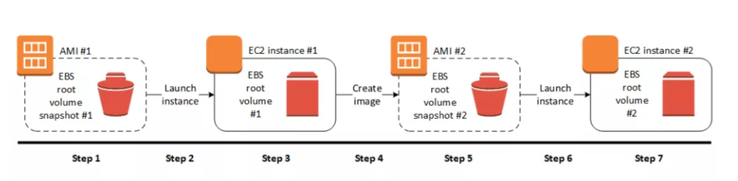

* EBS-Backed Linux AMI can be created from the instance directly or from the EBS snapshot
* EBS-backed linux AMI creation process :-
  1. Select an AMI #1 similar to what you want to have your new AMI #2
  2. Launch an Instance from AMI #1 and configure the instance accordingly
  3. Stop the instance to ensure data integrity and then create AMI #2 **OR**
  4. Create an EBS snapshot and then create an AMI #2 from the snapshot
  5. Amazon automatically register the EBS-backed AMI for you
  6. AMI #2 an be used to now launch new instances
* **By default, EC2 shuts down the instance, takes snapshots of any attached volumes, creates and registers the AMI, and then reboots the instance.**
* **Shut down & Reboot of the Instance can be prevented using the No reboot option, however the file system integrity of the created image can’t be guaranteed**
* EC2 creates snapshots of the instance’s root volume and any other EBS volumes attached to your instance. If any volumes attached to the instance are encrypted, the new AMI only launches successfully on instances that support Amazon EBS encryption
* For any additional instance-store volumes or EBS volumes, the block device mapping for the new AMI contains information for these volumes, and the block device mappings for instances that you launch from the new AMI automatically contain information for these volumes.
* While data on EBS volumes persists, the Instance-store volumes specified in the block device mapping for the new instance are new and don’t contain any data from the instance store volumes of the instance you used to create the AMI.
* Its more efficient to create an EBS-backed AMI with EBS snapshots already taken as the snapshot created during AMI creation is just an incremental one
* **You are charged for the storage of both the AMI and the snapshots**

### **Instance Store-Backed Linux AMI**

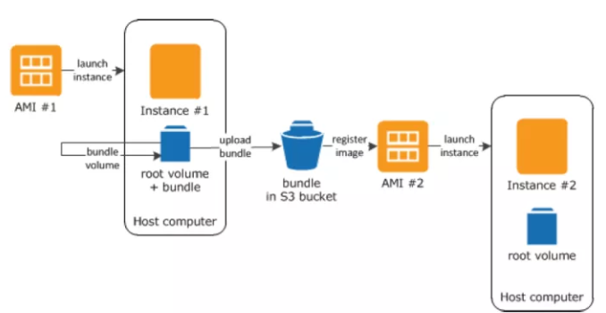

* Instance Store-Backed Linux AMI creation process
  1. Select an AMI #1 similar to what you want to have your new AMI #2
  2. Launch an Instance from AMI #1 and configure the instance accordingly
  3. Bundle the Instance. It takes several minutes for the bundling process to complete.
  4. After the process completes, you have a bundle, which consists of an image manifest (image.manifest.xml) and files (image.part.xx) that contain a template for the root volume.
  5. **Upload the bundle to your Amazon S3 bucket**
  6. Register the Instance Store-backed AMI.
  7. Launching an instance using the new AMI #2, the root volume for the instance is created using the bundle that you uploaded to Amazon S3.
* **Charges are incurred for rhe storage space used by the bundle in Amazon S3 until deleted**
* For additional instance store not root volumes, the block device mapping for the new AMI contains information for these volumes, and the block device mappings for instances that you launch from the new AMI automatically contain information for these volumes.

## Deregistering AMI

* Charges are incurred on the AMI created and they can be deregistered, if not needed.
* Deregistering an AMI does not delete the EBS snapshots or the bundles in the S3 buckets and have to be removed separately
* Once deregistered, new instances cannot be launched from the AMI. However, it does not impact already created instances from the AMI
* **Clean up EBS-Backed AMI**

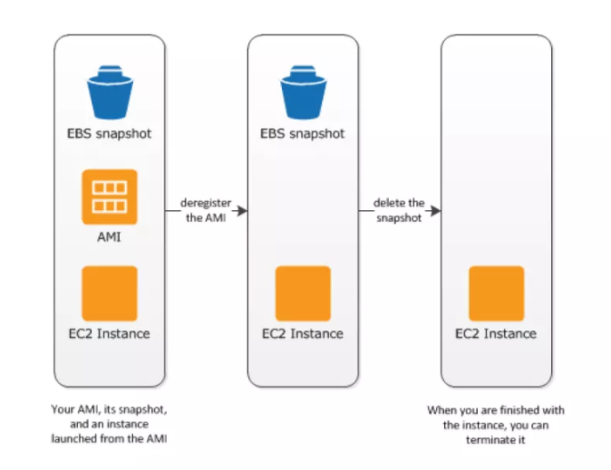

* + Deregister the EBS-Backed AMI
  + Delete the EBS Snapshot, as deregistering the AMI doesn’t impact the snapshot
* **Clean up Instance Store-backed AMI**

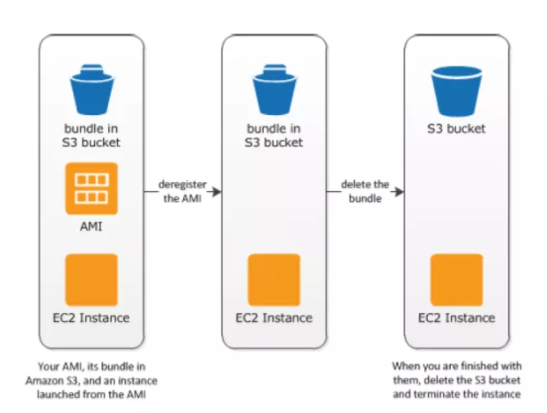

* + Deregister the EBS-Backed AMI
  + Delete the bundle from the S3 bucket, as deregistering the AMI doesn’t effect the bundles stored in the S3 bucket

## AMIs with Encrypted Snapshots

* AMIs, with EBS backed snapshots, can be attached with both an encrypted root and data volume
* AMIs copy image can be used to create AMIs with encrypted snapshots from AMIs with unencrypted snapshots. By default, copy image preserves the encryption status of the snapshots
* **Snapshots can be encrypted with either your default AWS Key Management Service customer master key (CMK), or with a custom key that you specify**

## AMI Copying

* Amazon EBS-backed AMIs and instance store-backed AMIs can be copied.
* Copying an AMI
  + An identical target AMI is created, but with its own unique identifier
  + For EBS Backed AMI, an identical but distinct root and data snapshots are created
  + Encryption status of the snapshots are preserved
  + However, Launch permissions, user-defined tags, or Amazon S3 bucket permissions are not copied from the source AMI to the new AMI. After the copy operation is complete, different launch permissions, user-defined tags, and Amazon S3 bucket permissions to the new AMI
* Source AMI can be deregistered without any impact to the Target AMI
* You can copy your owned AMIs, AMIs shared with you with proper permissions
* AMIs are created specific to a region and can be copied within or across regions which can help to aid in consistent global deployment and build highly scalable and available applications
* AMI copy image can be used to encrypt an AMI from an unencrypted AMI
* AMI copy image **can’t** be used to create an unencrypted an AMI from an encrypted AMI

EC2 Instance Types Overview

* **EC2 Instance types determines the hardware of the host computer used for the instance.**
* Each instance type offers different compute, memory, and storage capabilities and are grouped in instance families based on these capabilities
* EC2 provides each instance with a consistent and predictable amount of CPU capacity, regardless of its underlying hardware.
* EC2 dedicates some resources of the host computer, such as CPU, memory, and instance storage, to a particular instance.
* EC2 shares other resources of the host computer, such as the network and the disk subsystem, among instances. If each instance on a host computer tries to use as much of one of these shared resources as possible, each receives an equal share of that resource. However, when a resource is under-utilized, an instance can consume a higher share of that resource while it’s available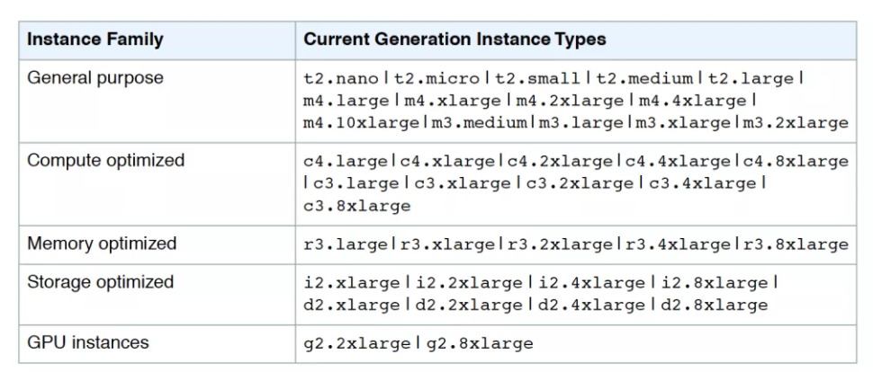

EC2 Instance Type selection criteria

* Some Instance types support only HVM virtualization type while others support both the PV and HVM virtualization types. **AWS, however, recommends using HVM for taking advantage of the underlying hardware**
* All the instances are available in a VPC, however, few instance types are not available in an EC2-classic. AWS recommends VPC to take advantage of enhanced networking, multiple IP addresses, finer security control etc.
* Some Instances types **support only EBS volumes, while others support both EBS and Instance store volumes**. Some instances that support instance store volumes use solid state drives (SSD) to deliver very high random I/O performance
* Some instances can be launched as **EBS optimized instances with a dedicated capacity for Amazon EBS I/O**
* Some instances can be launched in **placement group for to optimize instances for High Performance Computing**
* Some instance support Enhanced Networking,  to get significantly higher packet per second (PPS) performance, lower network jitter, and lower latencies
* Some Instances allow **EBS volumes to be encrypted**

EBS-Optimized

* EBS-optimized instance uses an optimized configuration stack and provides additional, dedicated capacity for EBS I/O
* EBS-optimized instances enable you to get consistently high performance for the EBS volumes by **eliminating contention between EBS I/O and other network traffic from the instance**
* EBS-optimized instances deliver dedicated throughput to EBS, with options between 500 Mbps and 4,000 Mbps, depending on the instance type you use.
* **When attached to an EBS–optimized instance, General Purpose (SSD) volumes are designed to deliver within 10 percent of their baseline and burst performance 99.9 percent of the time in a given year, and Provisioned IOPS (SSD) volumes are designed to deliver within 10 percent of their provisioned performance 99.9 percent of the time in a given year.**
* **EBS optimization can be enabled for an instance that is not EBS–optimized, by default**

Placement Groups

* A 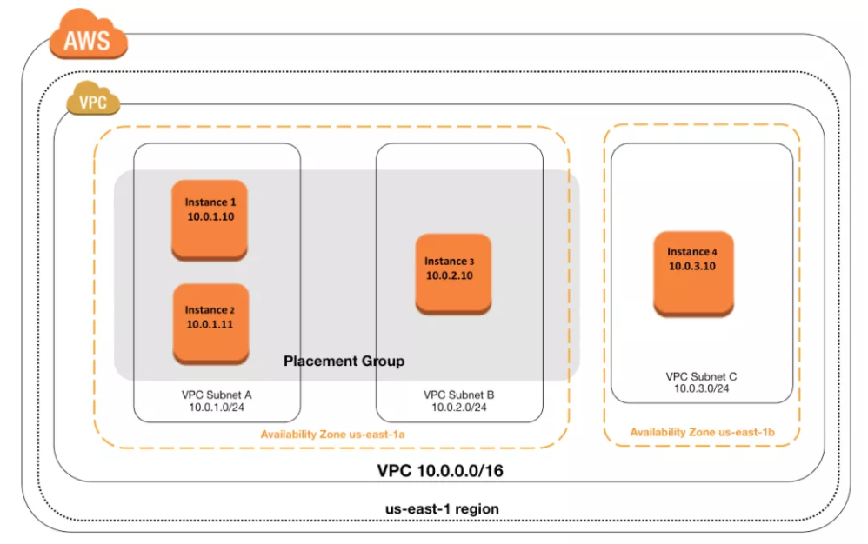Placement Group is a logical grouping of instances within a **single Availability Zone**and are recommended for applications that benefits from **low network latency, high network throughput**, or both.
* Placement group don’t span across Availability Zones
* Placement group is only available within a single Availability Zone either in the same VPC or peered VPCs
* Placement group is more of an hint to AWS that the instances need to be launched physically close to each together
* Using placement groups enables applications to participate in a low-latency, 10 Gbps network.

Placement Group Key Points

* Provides Low network latency & high network throughput and is recommened for HPC (High Performance Computing)
* **Should be in the same Availability Zone and can’t span multiple AZs**
* Should have unique name within AWS account
* To provide the lowest latency, and the highest packet-per-second network performance, choose instance type that supports enhanced networking
* Only [Specific Instance types](http://aws.amazon.com/ec2/instance-types/#instance-type-matrix) (General Purpose, GPU, Compute, Memory, Storage Optimized – m4.10xlarge, c4.8xlarge, c3.8xlarge, g2.8xlarge, r3.8xlarge, i2.8xlarge, d2.8xlarge)  which support 10 Gigabyte network performance can take full advantage of Placement Group
* Placement Groups cannot be merged. Instances in one placement group should be terminated, and then relaunched into an other placement group
* Existing EC2 instance can’t be moved into a Placement Group as it might be physically located away from the existing instances
* For moving an instance into the placement group,
  + create an AMI from the existing instance,
  + and then launch a new instance from the AMI into a placement group.
* AWS recommends using the same homogenous instance type for all instances in a placement group
* Placement group can span peered VPCs
* When launching an instance in the placement group results in a capacity error, stop and start the instances in the placement group and try to launch the instance again

Placement Groups Best Practices

* Use homogenous instance types
* Launch all the placement group instances at the same time
* Not a best fit for horizontally scalable web services
* Ensure there is enough capacity
* Jumbo frames help to achieve the maximum network throughput possible, and they are recommended for instances collocated inside a placement group

Instance Types

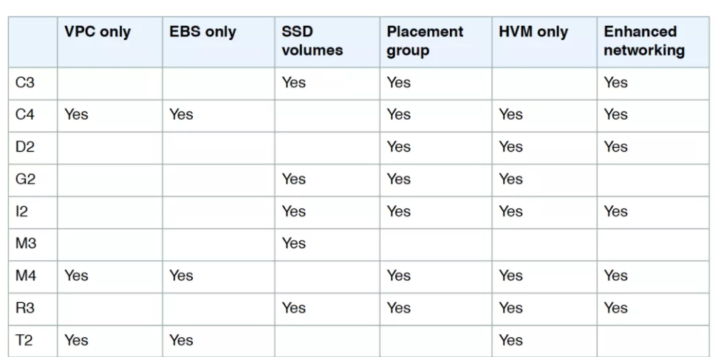

T2 Instances (General Purpose)

* T2 instances are designed to provide moderate baseline performance and the capability to burst to significantly higher performance as required by your workload.
* Mainly intended for workloads that don’t use the full CPU often or consistently, but occasionally need to burst.
* T2 instances are well suited for
  + general purpose workloads, such as web servers, developer environments, remote desktops and small databases
* Requirements
  + can be launched only with HVM AMI
  + can be launched into a  VPC only, and not supported on the EC2-Classic platform
  + are available as EBS-backed instances only
  + are available as On-Demand or Reserved instances, but do not allow spot instances
  + By default, 20 (soft limit) T2 instances can run simultaneously
  + cannot be launched as a Dedicated instance

CPU Credits

* CPU Credits (Similar to I/O Credits in case of the EBS general purpose storage) provides the performance of a full CPU core for one minute
* T2 instances provide a baseline level of CPU performance, while CPU governs the ability to burst above the baseline level
* One CPU credit is equal to one vCPU running at 100% utilization for one minute. *for e.g. you can have One vCPU running at 100% for One minute OR One vCPU running @ 50% for 2 minutes OR Two vCPU running @ 25% for 2 minutes*
* Each T2 instance receives a healthy initial credit balance for startup performance
* Initial CPU credits do not expire, but they are used first when an instance uses CPU credits.
* Each T2 instance then continuously (at a millisecond-level resolution) receives a set rate of CPU credits per hour, depending on instance size *for e.g. t2.nano earns 3/hour while a t2.large earns 36/hour*
* Each T2 instance accumulates the CPU credit when it uses fewer CPU resources than its allowed baseline performance levels
* Maximum earned credit balance for an instance is equal to the number of CPU credits received per hour times 24 hours *for e.g. t2.nano can earn max 72 (24 * 3) credits*
* CPU credit balance is available for a period of 24 hours and it expires 24 hours after they were earned. Expired credits are removed from the balance before new ones are added
* CPU credit cease to persist between an instance stop – start. However, after the start, the instance receives the initial CPU credits again
* When credit balance is completely exhausted, the instance will perform at its baseline performance

C4 Instances (Compute Intensive)

* C4 instances are ideal for compute-bound applications that benefit from high performance processors
* Well suited for
  + Batch processing workloads,
  + Media transcoding,
  + High-traffic web servers, massively multiplayer online (MMO) gaming servers, and ad serving engines,
  + High-traffic web servers, massively multiplayer online (MMO) gaming servers, and ad serving engines
* Features
  + **are EBS-optimized, by default**
  + can be enabled for Enhanced Networking capabilities
  + **can be clustered in a placement group**
* requirements
  + requires 64-bit HVM AMI
  + can be launched into a  VPC only, and not supported on the EC2-Classic platform

G2 Instances (Graphic Intensive)

* GPU instances provide  high parallel processing capability
* Well suited for
  + to accelerate many scientific, engineering, and rendering applications by leveraging the Compute Unified Device Architecture (CUDA) or OpenCL parallel computing frameworks
  + graphics applications, including game streaming, 3-D application streaming, and other graphics workloads
* Requirements
  + requires HVM AMI
  + can’t access GPU unless NVIDIA drivers installed
* Features
  + **can be clustered in a placement group**

I2 Instances (I/O Intensive)

* I2 instances are optimized to deliver tens of thousands of low-latency, random I/O operations per second (IOPS) to applications.
* Well suited for applications
  + NoSQL databases (for example, Cassandra and MongoDB)
  + Clustered databases
  + Online transaction processing (OLTP) systems
* Features
  + Primary data storage is SSD-based instance storage.
  + can be enabled for Enhanced Networking capabilities
  + **can be clustered in a placement group**
  + can enable EBS–optimization to obtain additional, dedicated capacity for Amazon EBS I/O
* Requirements
  + requires HVM AMI
* **HI1** is the equivalent previous generation instance
  + supports both PV and HVM AMIs

D2 Instances (Density Intensive)

* D2 instances are designed for workloads with very high storage density and that require high sequential read and write access to very large data sets on local storage.
* Well suited for applications
  + Massive parallel processing (MPP) data warehouse
  + MapReduce and Hadoop distributed computing
  + Log or data processing applications
* Features
  + Primary data storage for D2 instances is HDD-based instance storage
  + are EBS-optimized, by default
  + can be enabled for Enhanced Networking capabilities
  + can be clustered in a placement group
* requirements
  + requires 64-bit HVM AMI
* **HS1** is the equivalent previous generation instance
  + supports both EBS and Instance store backed AMIs
  + supports both PV and HVM AMIs

**EC2 Instance Metadata & Userdata**

* Instance metadata and user data can be used for Self Configuration allowing EC2 instance answer the question **Who am I ? What should I do ?**
* Instance metadata and user data can be accessed from within the instance itself
* Data is not protected by cryptographic methods. Anyone who can access the instance can view its metadata and should not be used to any store sensitive data, such as passwords, as user data.
* Both the metadata and user data is available from the IP address **169.254.169.254** and has the latest as well as previous versions available
* Metadata and User data can be retrieved using simple *curl* or*GET*command and these requests are not billed

Instance Metadata

* Instance metadata is data about the Instance and allows you to get answers to the **Who am I?**
* Instance metadata is divided into two categories
  + Instance metadata
    - includes metadata about the instance such as instance id, ami id, hostname, ip address, role etc
    - Can be accessed from http://169.254.169.254/latest/meta-data/
  + Dynamic data
    - is generated when the instances are launched such as instance identity documents, instance monitoring etc
    - Can be accessed from http://169.254.169.254/latest/dynamic/
* Instance metadata can be used for managing and configuring instances

User Data

* User data can be used for bootstrapping EC2 instance and helps answer the **What should I do?**
* User data is supplied when launching a EC2 instance and executed at boot time
* User data can be in the form of parameters or user defined script executed when the instance is launched *for e.g. perform software patch updates, load and update the application from an S3 bucket etc*
* User data can be used to build more generic AMIs which can then be configured at launch time dynamically
* User data can be retrieved from http://169.254.169.254/latest/user-data
* User data is executed only at the launch of the instance.
* If you stop an instance, modify the user data, and start the instance, the new user data is not executed automatically.
* User data is treated as opaque data and returned as is.
* User data is limited to 16 KB. This limit applies to the data in raw form, not base64-encoded form.
* User data must be base64-encoded before being submitted to the API. The EC2 command line tools perform the base64 encoding for you. The data is decoded before being presented to the instance.

Cloud-Init & EC2Config

* Cloud-Init and EC2Config provides the ability to parse the user-data script on the instance and run the instructions
* **Cloud-Init**
  + Amazon Linux AMI supports Cloud-Init, which is an open source application built by Canonical.
  + Cloud-Init is installed on Amazon Linux, Ubuntu and RHEL AMIs
  + Cloud-Init enables using the EC2 UserData parameter to specify actions to run on the instance at boot time
  + User data is executed on first boot using Cloud-Init if the user data begins with #!
* **EC2Config**
  + EC2Config is installed on Windows Server AMIs
  + User data is executed on first boot using Cloud-Init (technically EC2Config parses the instructions) if the user data begins with <script> or <powershell>
  + EC2Config service is started when the instance is booted. It performs tasks during initial instance startup (once) and each time you stop and start the instance.
  + It can also perform tasks on demand. Some of these tasks are enabled automatically, while others must be enabled manually.
  + EC2Config uses settings files to control its operation
  + EC2Config service runs Sysprep, a Microsoft tool that enables you to create a customized Windows AMI that can be reused.
  + When EC2Config calls Sysprep, it uses the settings files in EC2ConfigService\Settings to determine which operations to perform

EC2 Storage Overview

* Amazon EC2 provides flexible, cost effective and easy-to-use EC2 storage options with a unique combination of performance and durability
  + Amazon Elastic Block Store (EBS)
  + Amazon EC2 Instance Store
  + Amazon Simple Storage Service (S3)
* **While EBS and Instance store are Block level, Amazon S3 is an Object level storage**

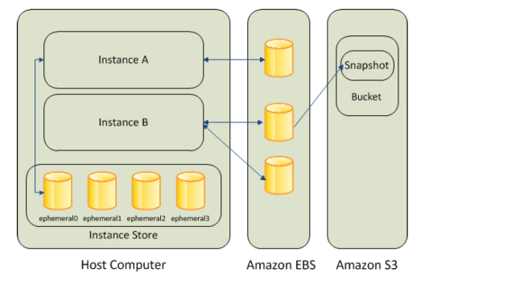

Storage Types

Amazon EBS

Amazon Instance Store

Amazon S3

Block Device Mapping

* A block device is a storage device that moves data in sequences of bytes or bits (blocks) and supports random access and generally use buffered I/O *for e.g. hard disks, CD-ROM etc*
* Block devices can be physically attached to a computer (like an instance store volume) or can be accessed remotely as if it was attached (like an EBS volume)
* Block device mapping defines the block devices to be attached to an instance, which can either be done while creation of an AMI or when an instance is launched
* Block device must be mounted on the instance, after being attached to the instance, to be able to be accessed
* When a block device is detached from an instance, it is unmounted by the operating system and you can no longer access the storage device.
* Additional Instance store volumes can be attached only when the instance is launched while EBS volumes can be attached to an running instance.
* View the block device mapping for an instance, only the EBS volumes can be seen, not the instance store volumes.Instance metadata can be used to query the complete block device mapping.

Public Data Sets

* Amazon Web Services provides a repository of public data sets that can be seamlessly integrated into AWS cloud-based applications.
* Amazon stores the data sets at no charge to the community and, as with all AWS services, you pay only for the compute and storage you use for your own applications.

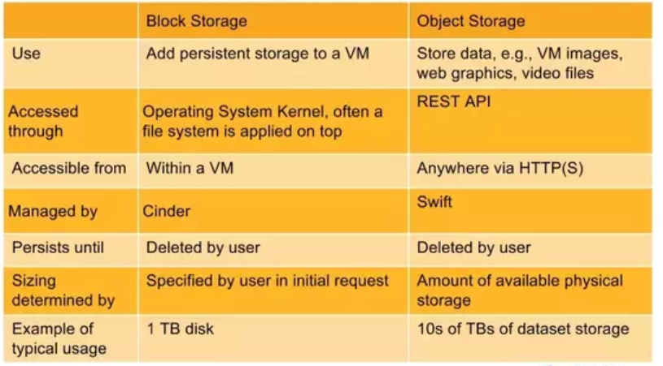

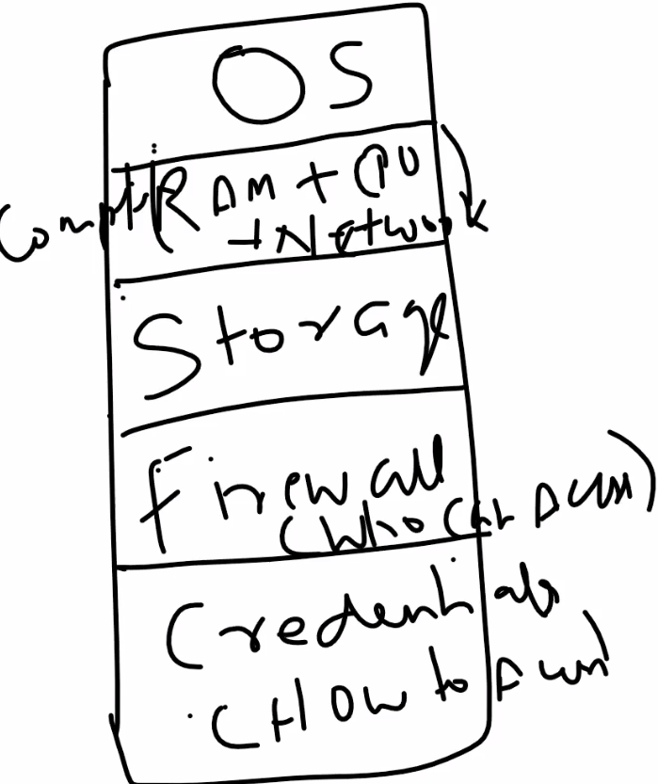

If we need to setup server on-premises, same thing goes as well on cloud..

There are about 10 Family/Classes.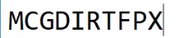

Let’s host a PHP website on EC2 and back it up with an RDS MySQL database.

**Step 1:**Login to AWS Management Console.

**Step 2:**Select a region from the drop down.

**Step 3:**Click EC2 under Compute section. This will take you to EC2 dashboard.

**Step 13:**Once you click connect, you will be prompted with the following screen. Copy the public IP and then click on Get Password.

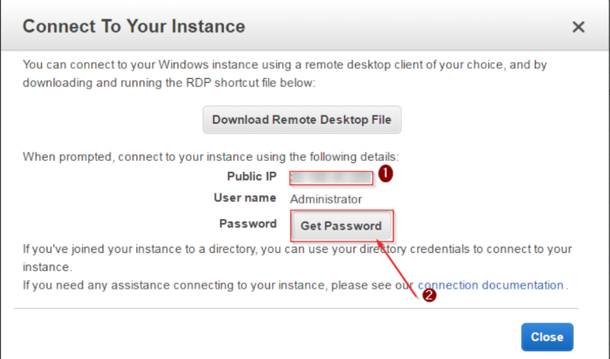

**Step 14:**Select the key-pair that you downloaded, then click decrypt password.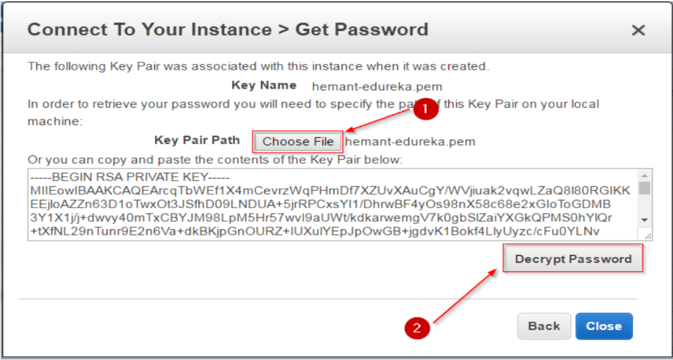

**Step 15:**Copy the password and the public IP, keep it handy for the next step.

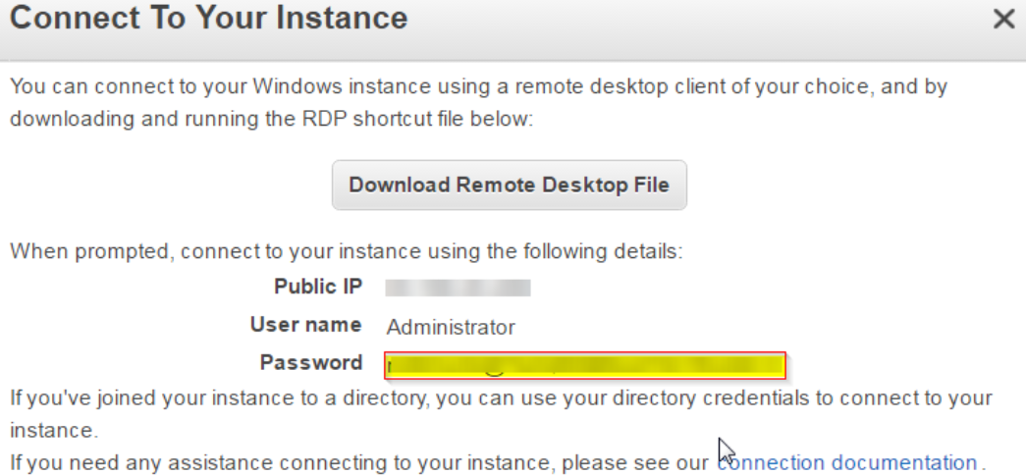

**Step 16:**We have the Public IP and the password now, let’s connect to our instance! Open the remote desktop manager. Enter the public IP address and click on Connect.

Next, **Let’s create a RDS instance for MySQL**

**Step 1:** Select the RDS service from the AWS Management Console.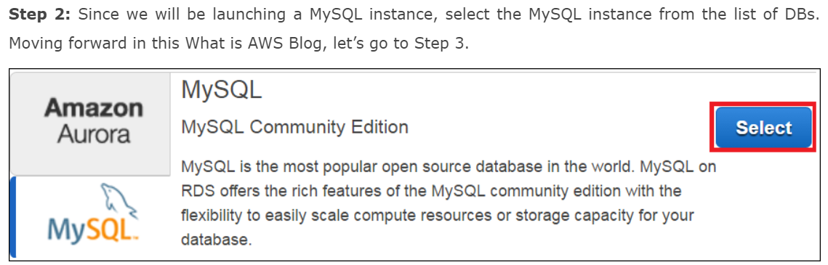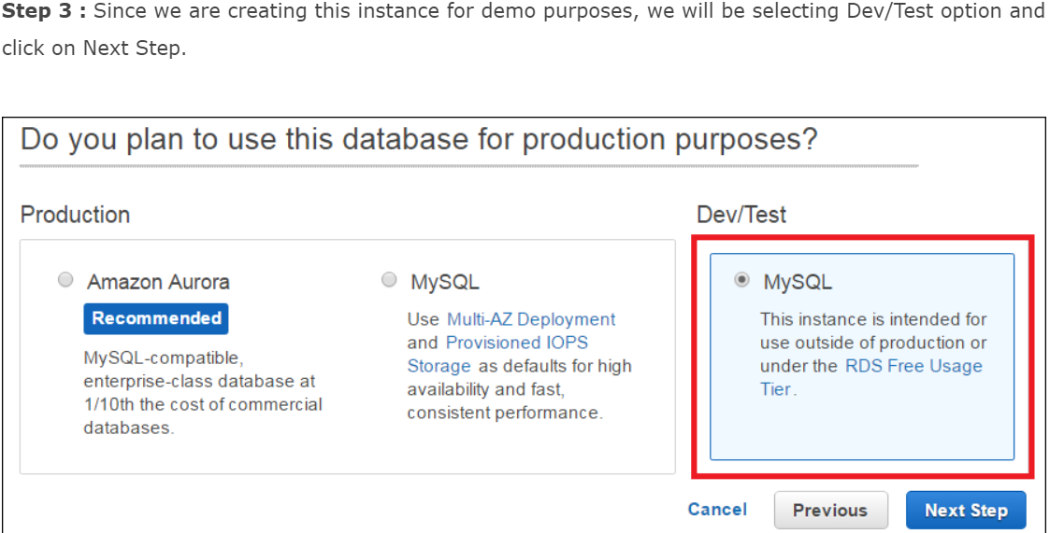

**Step 4 :**

On the next page you will be filling the following details:

* You can select your desired Db instance here
* You can select whether you want Multi-AZ enabled in your MySQL Db.
* You can select how much space you want to allocate to your Db instance, it can vary from 5GB to 6TB.
* In the end you will be setting your username and password for your Db Instance

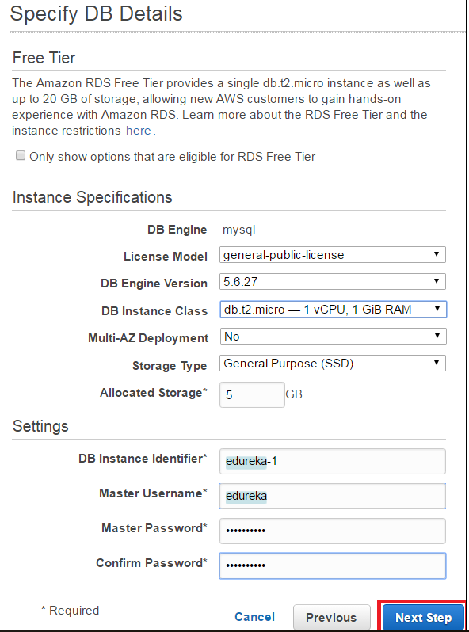

**Step 5 :**

In the next step, you will be configuring Advanced Settings for your DB

* You will be selecting the VPC here, if you do not wish to launch your instance in a VPC you can leave the default settings and move ahead.
* In the next section you can select which version of the Db you want to use, for our example we are using MySQL 5.6
* In the next section you can set your backup preferences, like the retention period etc.
* After that we will be setting the maintenance window, this is the time frame during which your Db instances will be updated.
* Once you fill all the details, you will be launching the Db instance!

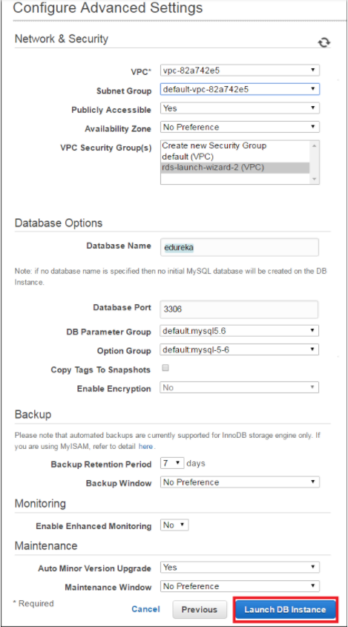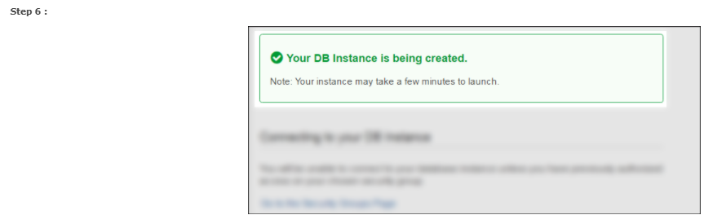

**Next in this What is AWS demo, let’s configure your RDS instance to connect to your EC2 server.**

**Step 1:** On your RDS Dashboard, select your RDS instance.

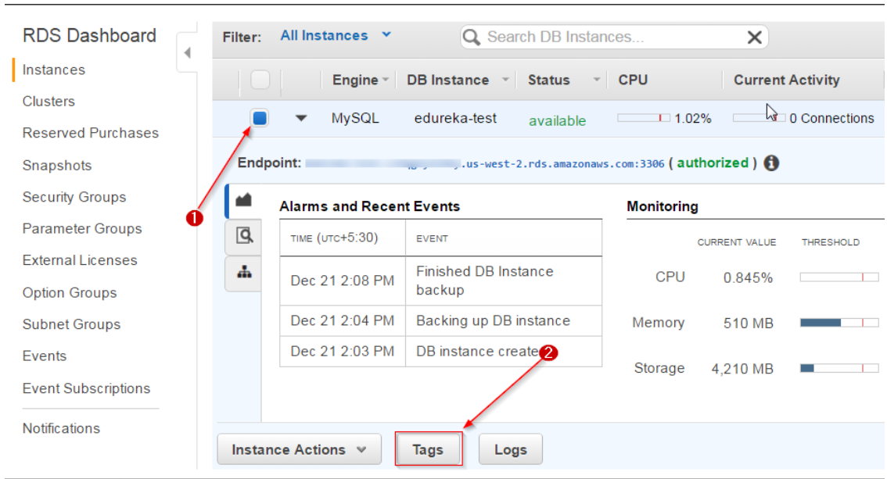

**Step 2:** You have to edit the Security Group here, Why? Because you want your EC2 instance to be able to connect to your RDS Instance, for that you have to add the IP address of your EC2 instance here.

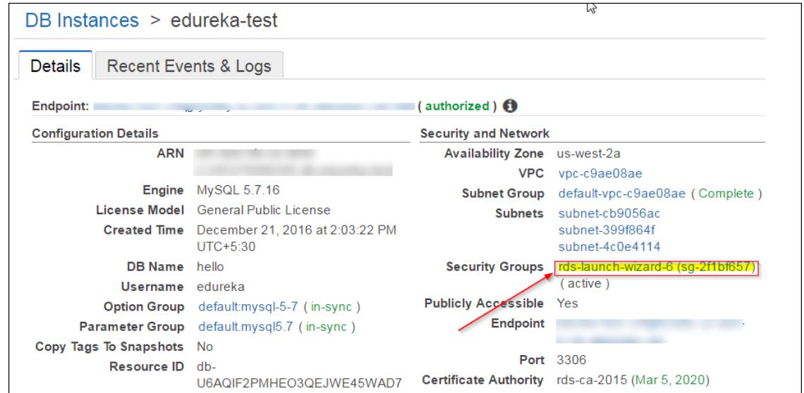

**Step 3:** Select the Security group, then select the Inbound rules, then click on Edit.

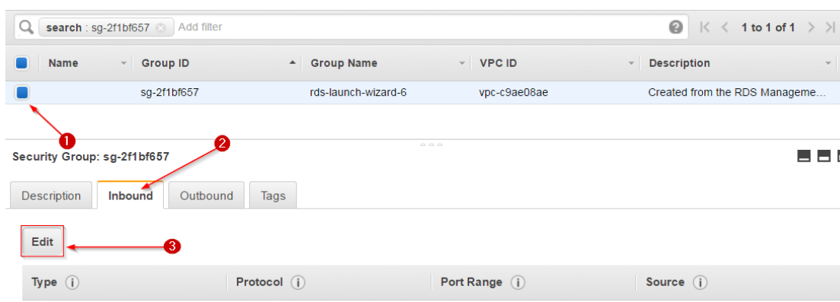

**Step 4:** Select the MySQL/Aurora, and then enter the Public IP address of your EC2 instance in the second field. Any IP address that you enter here should be followed by a ‘/32’ to convert it into CIDR notation. In the end Click Save.

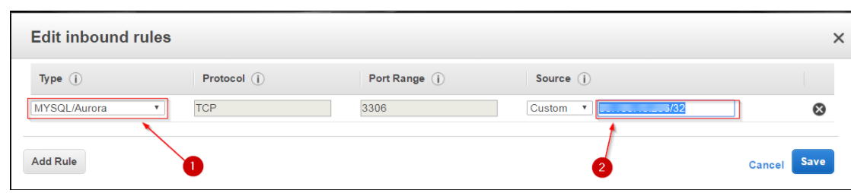

That’s it! Your RDS instance is ready to receive commands from your EC2 instance.

What next? You would need a MySQL Workbench or a server to connect to your RDS instance. I installed MySQL on the EC2 instance itself, you can do that on your localhost too.

**Note:** If you are doing it on your localhost, be sure to add your IP address in the Security Group of your RDS instance, like we did in the above step in this What is AWS blog.

**Let’s connect to the RDS Instance Now!**

**Step 1:** Open the command prompt and navigate to the **bin** folder of your MySQL.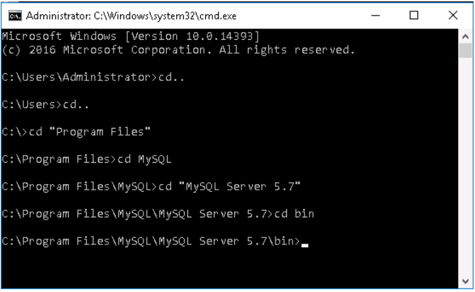

**Step 2:**Next up, copy the endpoint from your RDS instance dashboard, you will be needing this in the next step in this What is AWS blog demo to connect to your RDS instance. The endpoint is how your RDS instance gets identified. Following the endpoint is the port number ‘3306’ which you shall also need in the next step.

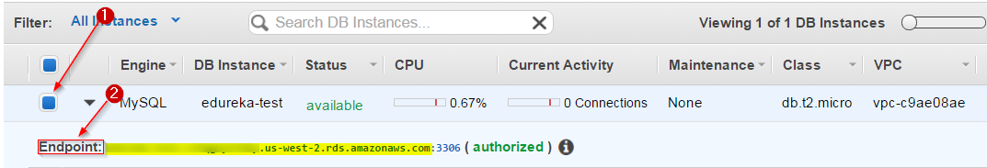

**Step 3:** Come back to the command prompt and type the following command, you will prompted for the password, enter the password that you entered while you created your RDS instance and you are set!

|  |  |
| --- | --- |
| 1 | mysql -h xx.rds.amazonaws.com -P <port number> -u <username> -p |

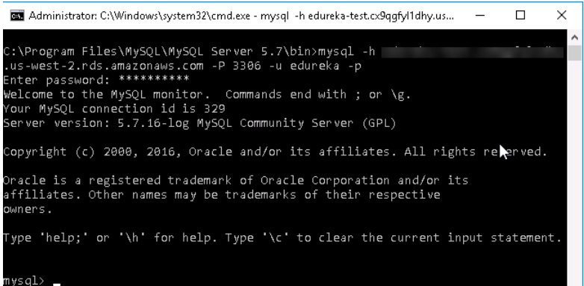

You can create your database and relevant tables here, I have already created mine, for your reference I am creating the sample ones here.

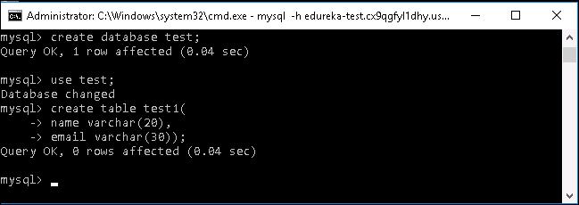  
Your RDS service is set now!

**Let’s move on, to the most exciting part of this What is AWS blog! Hosting your website!!**

**Step 1:** On your EC2 instance, click on start and then Server Manager.

**Step 2:** Click on Add roles and features.

**Step 3:** Click on next on the first page, on the second page, select the following option and click Next.

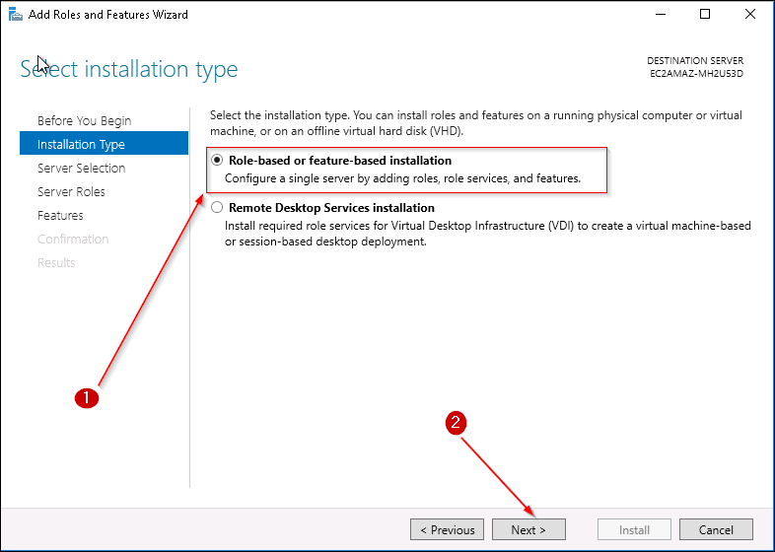

**Step 4:**Select the server pool option and click on Next. 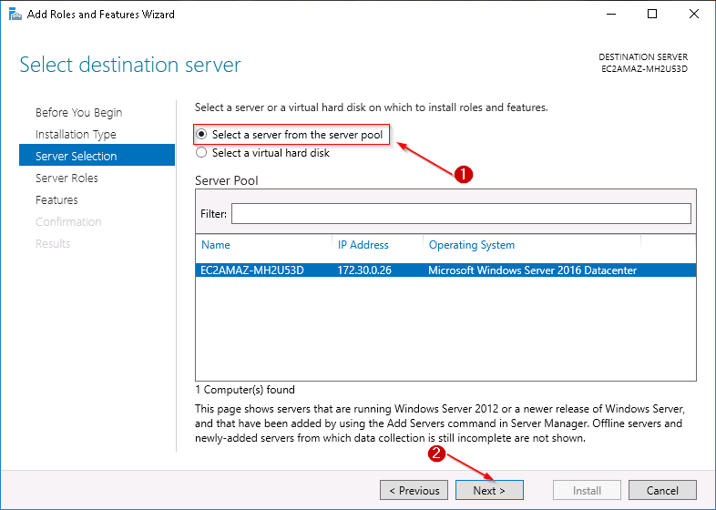

**Step 5:**Select the web server IIS from the list and click on Next. 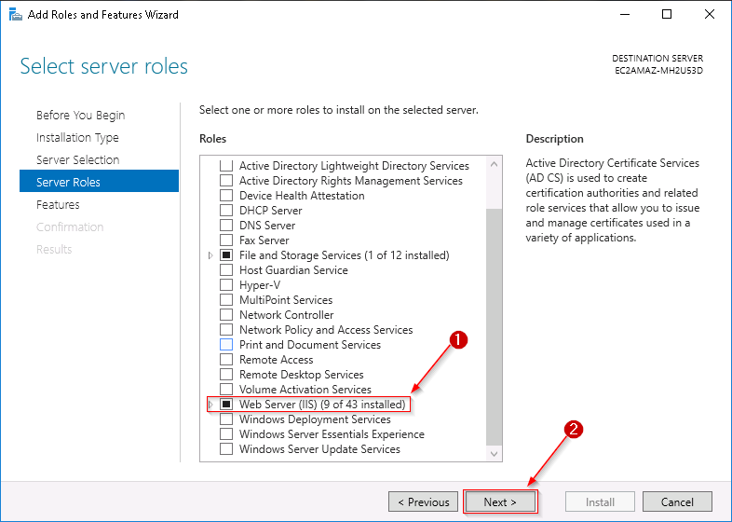

**Step 6:**Select the .NET Frameworks mentioned here, and click next.

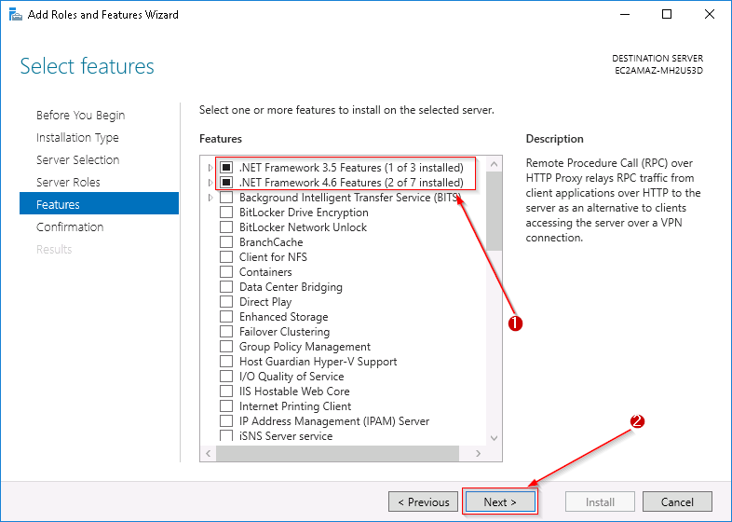

**Step 7:**This is the confirmation page, go through what is getting installed, and Click on Install.

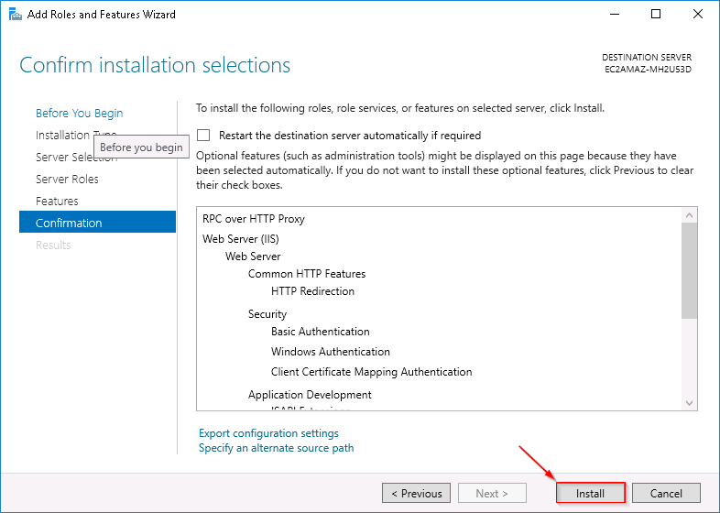

Once IIS is installed, you will be able to see it on your server manager dashboard.

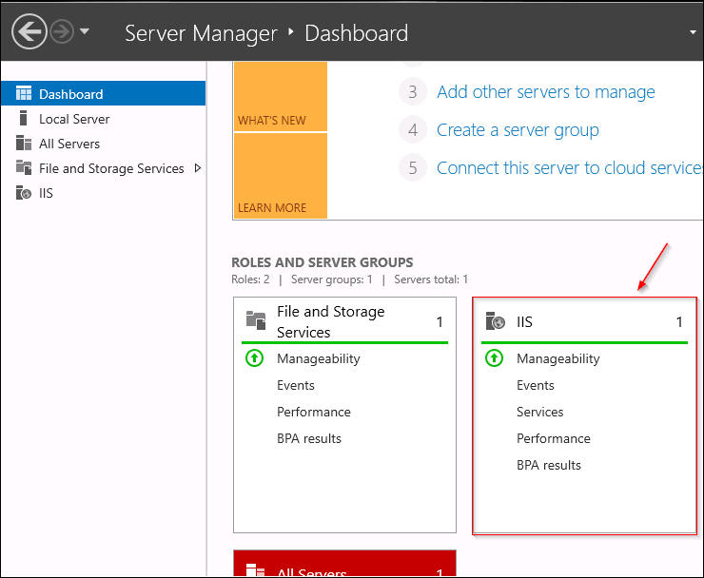

After this, install Microsoft Web Platform Installer from [here](https://www.microsoft.com/web/downloads/platform.aspx?lang=).

**Step 8:** Open IIS now, double click the server, and click on the web platform installer from the Management Section.

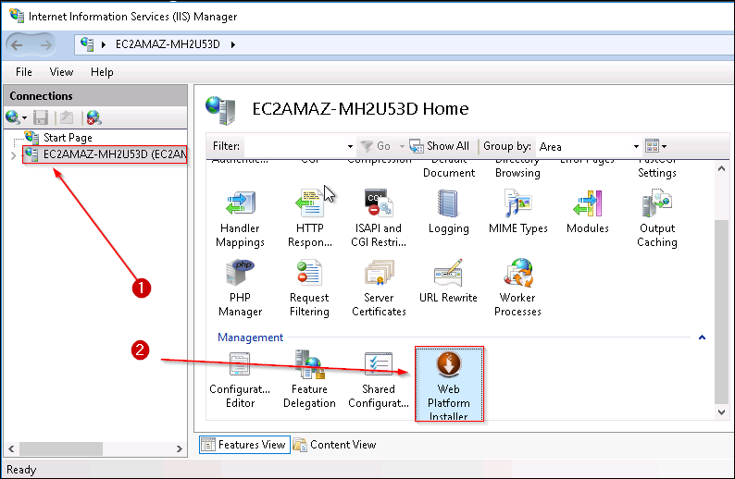

We will be deploying a PHP web application, therefore we need PHP installed on this server, therefore we would be needing Web Platform Installer.

**Step 9 :**Search for PHP in the search bar of WPI, install the following package.

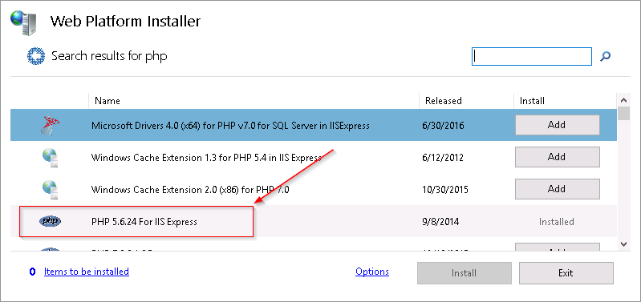

**\*Note:** If your PHP Manager is failing to install, there are some values that you have to change in the registry, you can refer this[post](http://stackoverflow.com/questions/21216228/php-manager-for-iis-fails-to-install).

**Step 10:**Once installed, you can view your PHP manager in IIS.

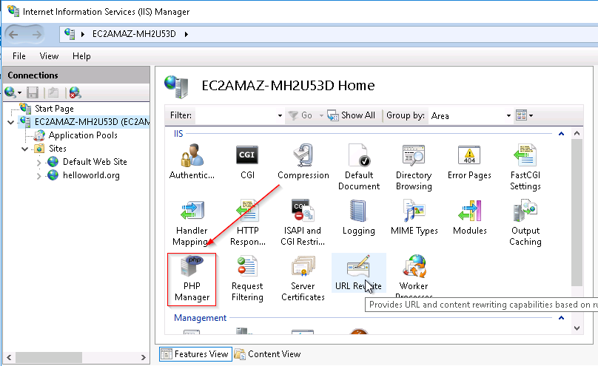

Your EC2 server is ready to host a website now!

**Let’s upload your website to this EC2 server.**

**Step 1:** First, copy all your files of your website to this folder in “C:/inetpub/wwwroot” on this server.

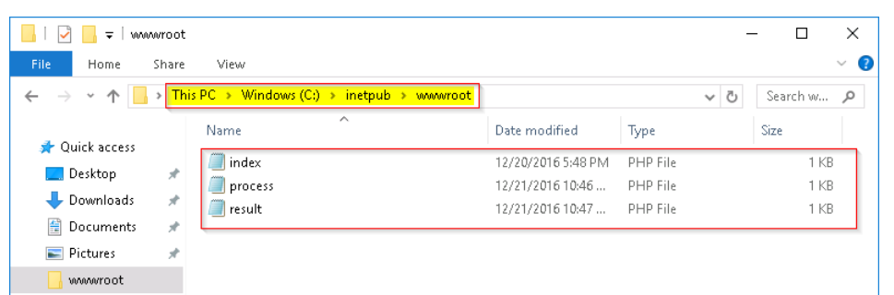

**Step 2:**Return to IIS, click on your server and then right click on Sites.

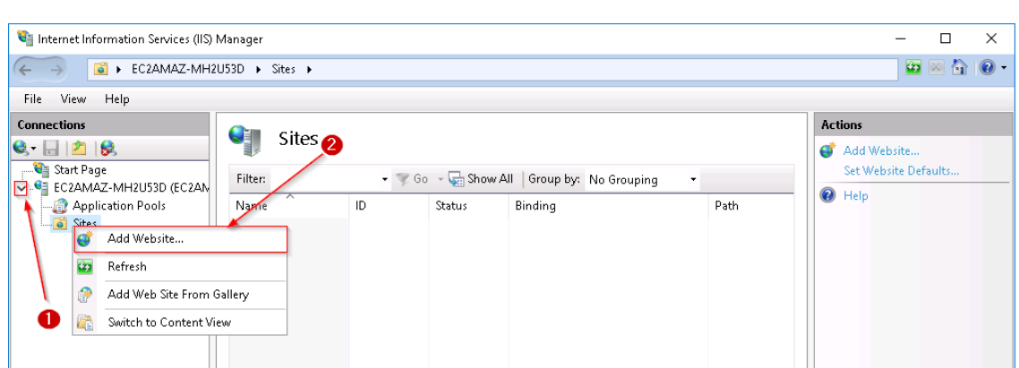

**Step 3:**In the ‘site name’ give a relevant name to your website, in the next step give the following physical path, and in the end click OK. 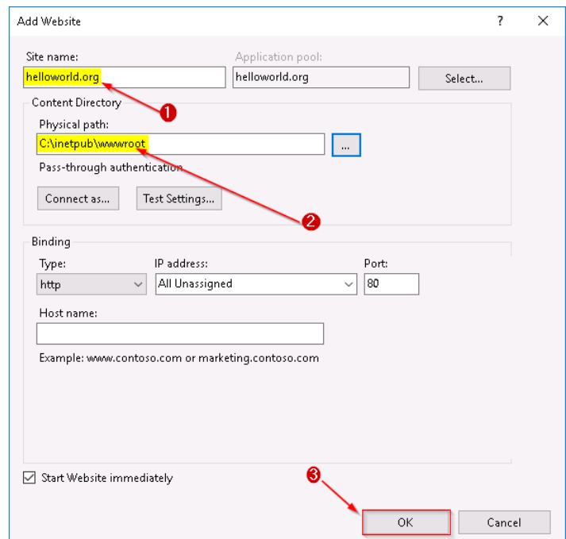

Your website is now live!

**Step 4 :**Enter the public IP address of your EC2 instance and voila! Your website is up and running. Enter the details and click on Add.

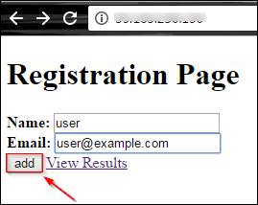

**Step 5 :**This shows that your RDS connection with your EC2 instance  is working well. So whatever you entered here, is getting stored on your RDS instance, and your website is stored on your EC2 instance. Click on Go Back.

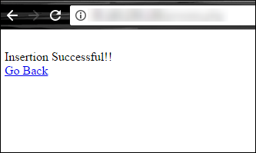

**Step 6 :** On the main page, click on View Results. And you shall see this page.

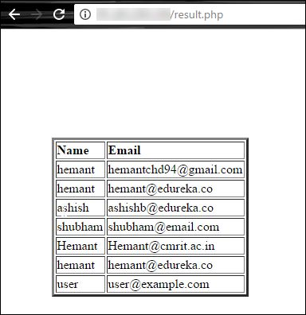

These are the records which are present in your MySQL table.

Need the code for this application? Here you go:

**index.php**

|  |  |
| --- | --- |
| 1  2  3  4  5  6  7  8  9  10  11  12 | <!DOCTYPE html>  <html>  <body>  <h1>Registration Page</h1>  <form action="process.php" method="post">  <b> Name: </b> <input type="text" name="name">  <b> Email: </b> <input type="text" name="email">  <input type="Submit" value="add">  <a href="result.php">View Results</a>  </form>  </body>  </html> |

**process.php**

|  |  |
| --- | --- |
| 1  2  3  4  5  6  7  8  9  10  11  12  13  14  15  16  17  18  19  20  21  22 | <html>  <body>  <?php  $name=$_POST['name'];  echo '<br />';  $email=$_POST['email'];  $hostname='edureka-test.cx9qgfyl1dhy.us-west-2.rds.amazonaws.com';  $username='edureka';  $password='hemant1994';  $dbname='edu_test';  $usertable='test';  $yourfield='name';  $con=mysqli_connect($hostname,$username, $password) OR DIE ('Unable to connect to database! Please try again later.');  mysqli_select_db($con,$dbname);  $query = "insert into ".$usertable." values('".$name."','".$email."');";  mysqli_query($con,$query) or die("Not Updated!");  echo "Insertion Successful!!";  ?>  <br>  <a href="index.php">Go Back</a>  </body>  </html> |

**result.php**

|  |  |
| --- | --- |
| 1  2  3  4  5  6  7  8  9  10  11  12  13  14  15  16  17  18  19  20  21  22  23  24  25  26  27 | <html>  <?php  $hostname='edureka-test.cx9qgfyl1dhy.us-west-2.rds.amazonaws.com';  $username='edureka';  $password='hemant1994';  $dbname='edu_test';  $usertable='test';  $yourfield1='name';  $yourfield2='email';  var_dump(function_exists('mysqli_connect'));  $con=mysqli_connect($hostname,$username, $password) OR DIE ('Unable to connect to database! Please try again later.');  mysqli_select_db($con,$dbname);  $query = 'SELECT * FROM test';  $result = mysqli_query($con,$query);  echo '<body><center><table><table border=3><tr><td><b>Name</b></td><td><b>Email</b></td></tr>';  if($result) while($row = mysqli_fetch_array($result)){  $name = $row[$yourfield1];  $email= $row[$yourfield2];  echo '<br>';  echo '<tr><td>' . $name . '</td>' ;  echo ' <td> ' . $email . '</td></tr>' ;  }  ?>  </table>  <a href="index.php"> Go Back </a>  </body>  </html> |